**PSI AP Physics I**

*Work and Energy*

Multiple-Choice questions

1. A driver in a 2000 kg Porsche wishes to pass a slow moving school bus on a 4 lane road. What is the average power in watts required to accelerate the sports car from 30 m/s to 60 m/s in 9 seconds?

A. 1,800

B. 5,000

C. 100,000

D. 300,000

1. A force F is at an angle θ above the horizontal and is used to pull a heavy suitcase of weight mg a distance d along a level floor at constant velocity. The coefficient of friction between the floor and the suitcase is μ. The work done by the force F is:

A. Fdcos θ - μ mgd

B. Fdcos θ

C. -μ mgd

D. 2Fdsin θ - μ mgd

1. A force of 20 N compresses a spring with a spring constant 50 N/m. How much energy is stored in the spring?

A. 2 J

B. 4 J

C. 5 J

D. 6 J

1. A stone is dropped from the edge of a cliff. Which of the following graphs best represents the stone's kinetic energy KE as a function of time t?

A. 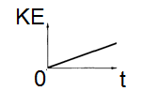B. 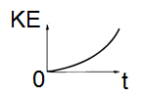C. 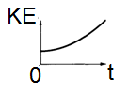D. 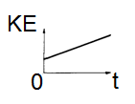

1. A 4 kg ball is attached to a 1.5 m long string and whirled in a horizontal circle at a constant speed 5 m/s. How much work is done on the ball during one period?

A. 9 J

B. 4.5 J

C. 2 J

D. 0 J

1. A student pushes a box across a horizontal surface at a constant speed of 0.6 m/s. The box has a mass of 40 kg, and the coefficient of kinetic friction is 0.5. The power supplied to the box by the person is:

A. 40 W

B. 60 W

C. 120 W

D. 150 W

1. You need to move three identical couches from the first to the second floor of an apartment building. The first time, you and a friend make a mistake and carry a couch up to the third floor and then back down to the second floor. The second couch is carried directly from the first to the second floor. On your third trip, you decide to put a ramp over the staircase and you both push the couch up the ramp to the second floor. During which trip did you perform the most work on the couch?

A. The first trip

B. The second trip

C. The third trip

D. The same work was performed for each trip.

1. A force F is applied in horizontal to a 10 kg block. The block moves at a constant speed of 2 m/s across a horizontal surface. The coefficient of kinetic friction between the block and the surface is 0.5. The work done by the force F in 1.5 minutes is:

A. 9000 J

B. 5000 J

C. 3000 J

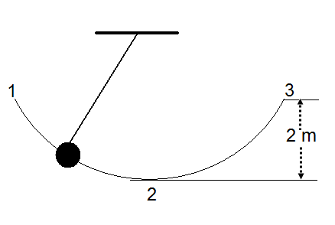D. 2000 J

Questions 9-10: A ball swings from point 1 to point 3 in the diagram to the right. Assume that the ball is in Simple Harmonic Motion and point 3 is 2 m above point 2 (the lowest point).

1. What happens to the kinetic energy of the ball when it moves from point 1 to point 2?

A. increases

B. decreases

C. remains the same

D. more information is required

1. What is the velocity of the ball at point 2?

A. 2.2 m/s

B. 3.5 m/s

C. 5.1 m/s

D. 6.3 m/s

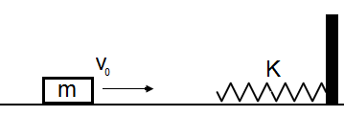

1. As shown above, a block with a mass of m slides at a constant velocity V0 on a horizontal frictionless surface. The block collides with a spring and comes to rest when the spring is compressed to the maximum value. If the spring constant is K, what is the maximum compression in the spring?

A. V0 (m/K)1/2

B. KmV0

C. V0K/m

D. V0 (K/m)1/2

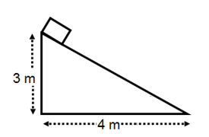Questions 12-13: A 2 kg block is released from rest from the top of an inclined plane, as shown in the diagram to the right. There is no friction between the block and the surface.

1. How much work is done by the gravitational force on the block?

A. 80 J

B. 60 J

C. 40 J

D. 20 J

1. What is the speed of the block when it reaches the horizontal surface?

A. 3.2 m/s

B. 4.3 m/s

C. 5.8 m/s

D. 7.7 m/s

1. A crane lifts a 300 kg load at a constant speed to the top of a building 60 m high in 15 s. The average power expended by the crane to overcome gravity is:

A. 10,000 W

B. 12,000 W

C. 15,000 W

D. 30,000 W

1. A satellite with a mass m revolves around Earth in a circular orbit with a constant radius R. What is the kinetic energy of the satellite if Earth’s mass is M?

A. ½ mv2

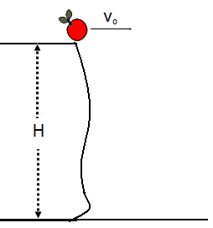B. mgh

C. ½GMm/R2

D. ½ GMm/R

Questions 16-17: An apple of mass m is thrown

horizontally from the edge of a cliff of height H,

as shown to the right.

1. What is the total mechanical energy of the apple with respect to the ground when it is at the edge of the cliff?

A. ½ mv02

B. mgH

C. mgH + ½ mv02

D. ½ mv02- mgH

1. What is the kinetic energy of the apple just before it hits the ground?

A. ½ mv02 + mgH

B. ½ mv02 - mgH

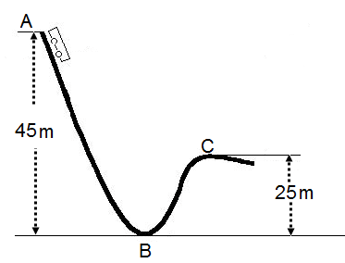C. mgH

D. ½ mv02

Questions 18-19: A 500 kg roller coaster car starts

from rest at point A and moves down the curved track, as shown to the right. Assume the track is frictionless.

1. Find the speed of the car at the lowest point B.

A. 10 m/s

B. 20 m/s

C. 30 m/s

D. 40 m/s

1. Find the speed of the car when it reaches point C.

A. 10 m/s

B. 20 m/s

C. 30 m/s

D. 40 m/s

1. Two projectiles A and B are launched from the ground with velocities of 50 m/s at 60 ̊ (projectile A) and 50 m/s at 30 ̊ (projectile B) with respect to the horizontal. Assuming there is no air resistance involved, which projectile has greater kinetic energy when it reaches the highest point?

A. projectile A

B. projectile B

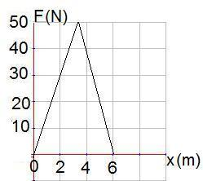C. they both have the same non-zero kinetic energy

D. they both have zero kinetic energy

Questions 21-22: An object with a mass of 2.0 kg is

initially at rest at a position x = 0. A non constant force F

is applied to the object over a displacement of 6.0 m, as

shown in the graph to the right.

1. What is the total work done on the object at the end of 6.0 m?

A. 200 J

B. 190 J

C. 170 J

D. 150 J

1. What is the velocity of the object at x = 6.0 m?

A. 300 m/s

B. 150 m/s

C. 25 m/s

D. 12 m/s

1. A metal ball is held stationary at a height h0 above the floor and then thrown downward. Assuming the collision with the floor is elastic, which graph best shows the relationship between the net energy E of the metal ball and its height h with respect to the floor?

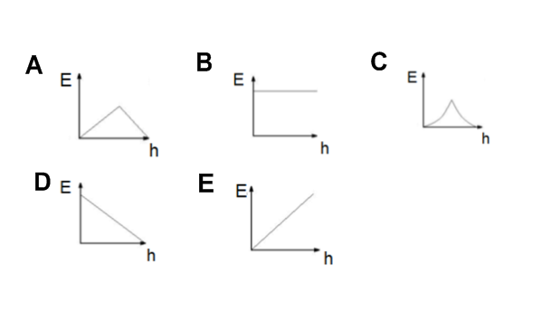

1. 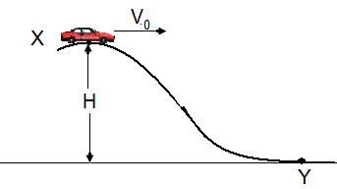A toy car travels with speed V0 at point X. Point Y is a height H below point X. Assuming there is no frictional losses and no work is done by the motor, what is the speed at point Y?

A. (2gH+ ½ V02)1/2

B. V0-2gH

C. (2gH + V02)1/2

D. 2gH+ (½V02)1/2

1. A rocket is launched from the surface of a planet with mass M and radius R. What is the minimum velocity the rocket must be given to completely escape from the planet’s gravitational field?
2. (2GM/R)1/2
3. (2GM/R)3
4. (GM/R)1/2
5. 2GM/R
6. 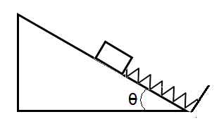A block of mass m is placed on the frictionless inclined plane with an incline angle θ. The block is just in a contact with a free end on an unstretched spring with a spring constant k. If the block is released from rest, what is the maximum compression in the spring:

A. kmg sinθ

B. kmg cosθ

C. 2mg sinθ /k

D. mg/k

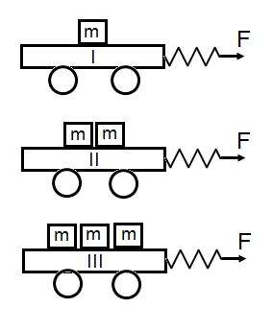Questions 27-29: In a physics lab, a student uses three

light, frictionless wheeled carts as shown to the right. Each cart is

loaded with blocks of equal mass.

1. The same force F is applied to each cart and they move equal distances d. In which one of these three cases is more work done by force F?

A. cart I

B. cart II

C. cart III

D. the same work is done on each cart

1. The same force F is applied to each cart and they move equal distances d. Which cart will have more kinetic energy at the end of distance d?

A. cart I

B. cart II

C. cart III

D. all three will have the same kinetic energy

1. The same force F is applied to each cart and they move equal distances d. Which cart will move faster at the end of distance d?

A. cart I

B. cart II

C. cart III

D. all three will move with the same velocity

1. A box of mass M begins at rest with point 1 at a height of 6R, where 2R is the radius of the circular part of the track. The box slides down the frictionless track and around the loop. What is the ratio between the normal force on the box at point 2 to the box’s weight?

A. 1 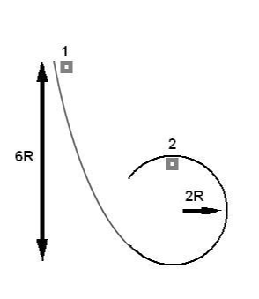

B. 2

C. 3

D. 4

1. 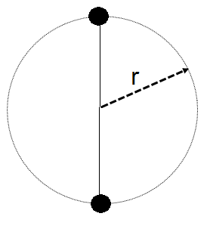A ball of mass m is fastened to a string. The ball is given an initial speed at the lowest point that is enough to move it in a vertical circle of radius r with the other end of the string held fixed. Assuming that there is no air resistance, the difference between the string’s tension at the bottom of the circle and at the top of the circle is:   
   A. mg

B. 2mg

C. 3mg

D. 6mg

Directions: For each of the following, two of the suggested answers will be correct. Select the best two choices to earn credit. No partial credit will be earned if only one correct choice is selected.

1. The following are characteristics of energy:   
   A. The amount of energy in an isolated system can be changed by an external force performing work on it.

B. Thermal energy can never be changed into mechanical energy.

C. Mechanical energy can be changed into thermal energy.

D. Energy is only present in an object when it is moving.

1. When analyzing work and energy problems, it is important to define the system and the environment in such a way as to make the problems easier to solve. The following are characteristics of a system:   
   A. Forces internal to the system can change its total mechanical energy.

B. A system can be one object or a collection of objects.

C. The system is external to the system boundary.

D. Objects cannot pass through the system boundary.

1. A constant force, F, is applied to a block sitting on a bench. There could be other forces acting on the block at the same time. In which of the following cases is no work done on the block by F?   
   A. The force is applied to the block, and it moves in the same direction as the force.

B. The force is applied to the block, and the block moves in the opposite direction of the force.

C. The block does not move.

D. The force is applied perpendicular to the block’s motion.

1. A student swings a ball around his head in a perfectly circular, horizontal orbit with a constant Tension. Which of the following is true concerning the ball’s orbit?   
   A. No work is done by the Tension force since the force is perpendicular to the ball’s motion.

B. The ball maintains a constant speed.

C. The ball maintains a constant velocity.

D. The ball’s speed increases due to the work done by the Tension force.

Multiple Choice Answer Key

* 1. D
  2. B
  3. B
  4. B
  5. D
  6. C
  7. D
  8. A
  9. A
  10. D
  11. A
  12. B
  13. D
  14. B
  15. D
  16. C
  17. A
  18. C
  19. B
  20. B
  21. D
  22. D
  23. B
  24. C
  25. A
  26. C
  27. D
  28. D
  29. A
  30. A
  31. D
  32. A, C
  33. B, D
  34. C, D
  35. A, B