**PSI AP Physics I**

**Work and Energy Chapter Questions**

1. Define a system, the environment and the system boundary.
2. Contrast the effects of external forces and internal forces on the total energy of a system.
3. Why do internal forces have no impact on the total energy of a system?
4. What are some characteristics of energy? Why cannot it be precisely defined?
5. A person is holding a box. Describe the work done by the person on the box in the following situations – in terms of zero, positive and negative work:
   1. The box is just being held and it is not moving.
   2. The person is lifting the box above his head.
   3. The person is lowering the box to the ground.
6. A person begins to lift up a box. Compare/contrast the work done on a box by the person person lifting it and by the gravitational field acting on the box as it is being lifted.
7. You are examining two systems; one is a closed system and the other is an open system. What is the main difference between the two? In which system does the Conservation of Energy hold true?
8. If work is done on a system, is energy conserved?
9. What is the advantage in solving motion problems using energy conservation principles instead of free body diagrams? Which cases are more easily solved using Conservation of Energy?
10. An object is being pulled across the ground with a force that makes an angle with the ground. Since Work depends only on the force parallel to the direction of motion, how can you solve for the Work performed by the force?
11. Describe how the equation for the Gravitational Potential Energy (GPE = mgh) was determined. Do objects near the surface of the planet Earth have an absolute value for GPE?
12. A method for determining the GPE of an object involves the Work-Energy Equation. What statement is made that relates the GPE and the work performed by the gravitational field?
13. When an object is pushed a distance, d, up an incline of total height, h, which value is used to calculate its GPE?
14. Why are free body diagrams and Newton’s Second Law not an easy way to solve motion problems involving a spring? Why is the Conservation of Energy a simpler way to solve them?
15. A roller coaster car traverses two vertical loops. Loop A is higher than Loop B. At the top of which loop will the car have a greater speed? Why?
16. Is the escape velocity from earth greater for a rocket or for a hydrogen atom? Why?
17. What assumptions are made about the kinetic energy and potential energy of an object when solving for the escape velocity?
18. Give two alternate equations for the Power generated by an object.

**Chapter Problems**

1. **Review of One Dimensional Forces, Work and Energy**

**Classwork**

1. A block is pushed 22.0 m along a frictionless horizontal surface by a force of 23.1 N. How much work does the force do on the block?
2. A person pushes a stroller a distance of 9.5 m while performing 350 J of work on the stroller. Find the applied force exerted by the person.
3. A 3.2 kg textbook is lifted 1.3 m by a student. What work is done by the student on the textbook?
4. A 3.2 kg textbook is lifted 1.3 m by a student. What work is done by the force of gravity on the textbook?
5. The same 3.2 kg textbook is held stationary by the student for 42 s. How much work is done by the student on the textbook?
6. An automobile of mass 1620 kg, initially at rest, is accelerated by the force of the engine to a velocity of 24.6 m/s. How much work was done on the automobile to achieve that velocity?
7. Over what distance must a 360 N force be applied to an object so that it gains 2200 J of energy?
8. How much work must be done to a truck of mass 3580 kg to accelerate it from 21 m/s to 24.6 m/s?

**Homework**

1. A construction worker pulls a cart full of bricks a distance of 21 m, using a horizontal force of 920 N. How much work does the worker do on the cart?
2. A wagon of mass 42 kg is pushed by a student a distance of 12.2 m, and 297 J of work was done on the wagon. How much force did the student apply, assuming that it was constant?
3. Cables lift an elevator car of mass 922 kg a distance of 19.7 m. How much work was done by the cables on the car?
4. Cables lift an elevator car of mass 922 kg a distance of 19.7 m. How much work was done by the gravitational force on the car?
5. An elevator is stopped at a floor to let the people out. How much work is done by the support cables on the car while the car is stationary?
6. An automobile of mass 1450 kg is slowed from a velocity of 24.6 m/s to 9.6 m/s as it enters a residential area. What work was done on the automobile by the brakes?
7. If a truck loses 5610 J of energy as it slows down due to an external force of 425 N, what distance will it have moved after the force is first applied?
8. A truck of mass 3120 kg is accelerated from rest to a speed of 22.1 m/s. How much work was done on the truck to achieve that speed?
9. **Two Dimensional Forces and Work**

**Classwork**

1. A 62.3 N force pulls an object at an angle of θ = 22.0° to its direction of horizontal motion. It moves a distance of Δx = 12.1 m. How much work is done by the force on the object?
2. A 426 N force, applied at an angle of 46.2° to the horizontal slows down a moving cart. The cart moves another 14.3 m after the force application before coming to a stop. How much work was done by the force on the cart?
3. A wagon is pushed with an applied force of 123 N at an angle of θ = 35.4° to the horizontal and it moves Δx = 6.32 m. How much work is performed by the force on the wagon?
4. What force is required to be applied at an angle of 52.0° to the horizontal to perform 822 J of work in moving an object 6.80 m horizontally?
5. You want to move a 32.0 kg box up to the second floor of a building (Δy = 4.20 m) and you are calculating how much force you will need if you carry it up the stairs or if you set a frictionless ramp on the stairs and push it up the ramp. The ramp would be set at an angle of 45.0° to the horizontal. Assume the box is moved at a constant velocity.
   1. How much force do you need to apply if you carry it up in your arms?
   2. How much force is required if you push it up the frictionless ramp?
   3. How much work is done in each case?

**Homework**

1. A block moves a distance of Δx = 8.62 m as it is pulled by a 28.3 N force at an angle of θ = 34.5° to its direction of horizontal motion. How much work is done by the force on the object?
2. A 352 N force, applied at an angle of 38.2° to the horizontal slows down a moving wagon. The wagon moves another 12.1 m after the force is applied before coming to rest. How much work was done by the force on the wagon?
3. A wagon is pushed with an applied force of 284 N at an angle of θ = 48.1° to the horizontal and it moves Δx = 8.91 m. How much work is done by the force on the wagon?
4. What magnitude of force is required to be applied at an angle of 32.0° to the horizontal to perform 651 J of work in moving an object 7.20 m horizontally?
5. You want to move a 21.0 kg fish tank up to the second floor of a building (Δy = 4.40 m) and you are calculating how much force you will need if you carry it up the stairs or if you set a frictionless ramp on the stairs and push it up the ramp. The ramp will be set at an angle of 45.0° to the horizontal. Assume the tank is moved at a constant velocity.
   1. How much force do you need to apply if you carry it up in your arms?
   2. How much force is required if you push it up the frictionless ramp?
   3. How much work is done in each case?
6. **Gravitational Potential Energy**

**Classwork**

1. What is the change in GPE for a 4.2 kg physics textbook that is lifted from a height of 0.85 m above the floor to a height of 1.8 m above the floor?
2. A bookend of mass 0.48 kg is lowered from a bookshelf that is 1.3m above the floor to a shelf that is 0.32 m above the floor. What is its change in GPE?
3. How high must a basketball of mass 0.62 kg be lifted to increase its GPE by 6.7 J?
4. A box is lifted 2.2 m above its initial height and its GPE increases by 7.2 J. What is the mass of the box?
5. An elevator car of mass 810 kg moves from the 9th floor to the 1st floor (a distance of 32 m) of a building at a constant velocity.
   1. What is the change in the elevator car’s GPE?
   2. What is the work done by the motor lowering the car?
   3. What is the work done by gravity on the car?
   4. What is the net work done on the car if it started at rest and finished at rest?
6. A 7.2 m long ramp is set at an angle of 42° with the floor. An 11 kg box is pushed up the ramp. What is the change in GPE of the box?
7. A 14 kg tricycle slides down a 6.2 m ramp that makes an angle of 22° with the ground. What is the change in GPE of the tricycle?
8. A ramp is set at 32° to the ground. A briefcase of mass 3.2 kg is pushed to the top of the ramp, increasing its GPE by 37 J. How long is the ramp?

**Homework**

1. A calculator of mass 0.11 kg is lowered from a bookshelf that is 1.6 m above the floor to a desk that is 0.85 m above the floor. What is its change in GPE?
2. What is the change in GPE for a 5.6 kg lamp that is lifted from the ground to a height of 1.9 m?
3. A bowling ball is lifted 1.2 m above its initial height, increasing its GPE by 62 J. What is the mass of the bowling ball?
4. A 3.1 kg carton’s GPE was increased by 7.8 J as it was lifted above the ground. How high was it lifted?
5. A telephone lineman of mass 98 kg climbs a telephone poll that is 18.2 m high.
   1. What is the increase in the lineman’s GPE?
   2. What is the work done the lineman’s muscles in climbing the pole?
   3. What is the work done by gravity on the lineman?
   4. What is the net work done on the lineman if she started at rest and finished at rest?
6. A 9.3 m long ramp is set at an angle of 18° with the floor. A 140 kg couch is pushed up the ramp. What is the change in GPE of the couch?
7. An 82 kg chair slides down a 5.2 m ramp that makes an angle of 320 with the ground. What is the change in GPE of the chair?
8. An object gains 37 J of energy as it is pushed to the top of a 4.2 m long ramp set at an angle of 23° to the horizontal. What is its mass?
9. **GPE, Kinetic Energy and Elastic Potential Energy**

**Classwork**

1. A marble launcher fires a marble at an angle of 50° to the horizontal with an initial velocity of 6.2 m/s. Assuming no air friction, what is the maximum height above the launcher’s muzzle that the marble reaches?
2. After being fired by a marble launcher at an angle of 38°, the marble reaches a maximum height of 1.4 m above the exit of the barrel. What was the velocity of the marble when it left the launcher?
3. The spring in a marble launcher is compressed 0.080 m by a marble of mass 0.0051 kg and is locked in. The launcher makes an angle of 62° with the horizontal. The spring is released and the marble exits the launcher. How much did the GPE of the marble change as it moved from the compressed to the released position of the spring (Δx = 0.080 m) along the barrel of the launcher?
4. What is the spring constant of a marble launcher that shoots a 0.0051 kg marble a height of 2.3 m above its muzzle assuming it is angled at 62° above the horizontal? The marble compressed the spring 0.080 m before being released.
5. A .012 kg block of wood sits on a frictionless incline on a spring, as shown in the diagram below. The block is pushed down, so it compresses the spring by Δx = 0.075 m, and is then released. What is the velocity of the block when it passes its original position on its way up the incline? θ = 28°. The spring constant is 220 N/m.

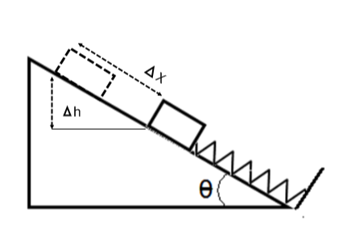

**Homework**

1. After being fired by a marble launcher at an angle of 67°, the marble reaches a maximum height of 2.3 m above the exit of the barrel. What was the velocity of the marble when it left the launcher?
2. A marble launcher fires a marble at an angle of 28° to the horizontal with an initial velocity of 7.6 m/s. Assuming no air friction, what maximum height above the launcher’s muzzle does the marble reach?
3. What is the spring constant of a marble launcher that shoots a 0.0073 kg marble a height of 3.3 m above its muzzle assuming it is angled at 36° above the horizontal? The marble compressed the spring 0.095 m before being released.
4. The spring in a marble launcher is compressed 0.078 m by a marble of mass 0.0045 kg and is locked in. The launcher makes an angle of 54° with the horizontal. The spring is released and the marble exits the launcher. How much did the GPE of the marble change as it moved from the compressed to the released position of the spring along the barrel of the launcher (0.078 m)?
5. A .028 kg block of wood sits on a frictionless incline on a spring, as shown by the diagram below. The block is pushed down, so it compresses the spring by Δx = 0.088 m, and then released. What is the velocity of the block when it passes its original position on its way up the incline? θ = 51°. The spring constant is 195 N/m.



1. **Conservation of Energy Problem Solving**

**Classwork**

1. A volleyball of mass 0.28 kg is dropped from the top of the bleachers (height equals 12 m). What is the speed of the volleyball right before it hits the gym floor?
2. A marble launcher is set up to launch marbles in the horizontal direction. It has a spring constant of 190 N/m and a marble of mass 0.0059 kg is loaded and compresses the spring 0.071 m. What is the speed of the marble when it exits the launcher?
3. A small box of mass 0.021 kg compresses a spring (k = 420 N/m) a distance of 0.070 m and is released. It travels on a horizontal, frictionless track and then enters a vertical loop. The loop has a radius of 0.24 m. What is the speed of the block when it reaches the top of the loop?
4. A small block is at the top of a frictionless track. The track slopes down, runs horizontally and then ends in a spring attached to a stop. The block is released, slides down the track and compresses the spring. How much is the spring compressed before it springs back and reverses the direction of the block? (Block mass = .035 kg, track height = 0.78 m, k= 380 N/m).

**Homework**

1. A basketball of mass 0.62 kg is dropped from the top of the bleachers (bleacher height = 12 m). What is the speed of the basketball before it hits the gym floor? Assume no air friction, how does this compare to the velocity of a volleyball of mass 0.28 kg dropped from the same height?
2. A spring loaded dart gun is set up to launch plastic darts in the horizontal direction. It has a spring constant of 230 N/m and a dart of mass 0.0088 kg is loaded and compresses the spring 0.092 m. What is the speed of the dart when it exits the launcher?
3. A small box of mass 0.015 kg compresses a spring (k = 430 N/m) a distance of 0.080 m and is released. It travels on a horizontal, frictionless track and then enters a vertical loop of radius 0.31 m. What is speed of the block when it reaches the top of the loop?
4. A 0.042 kg block is at the top of a frictionless track of height 1.3 m. The block slides down the track and goes around a vertical track loop of radius 0.25 m. It exits that loop and then enters and goes around a second vertical track loop of radius 0.35 m. Find the velocity of the block at the top of both loops. Why are the velocities different?
5. **GPE and Escape Velocity**

(G = 6.67x10-11 Nm2/kg2, mEarth = 5.97x1024kg, rEarth = 6.38x106m, mMars = 6.42x1023kg, rMars = 3.39x106m,

mVenus = 4.87x1024kg, rVenus=6.05x106m)

**Classwork**

1. The Zarya Module (mass = 1.93x104 kg) was launched in 1998 at the Baikonur Cosmodrome in Kazakhstan and became the first part of the International Space Station (ISS). What was the gravitational potential energy (UG) of the Zarya module when it was on the launching pad?
2. What is UG for the Zarya module when in its orbit of 4.10x105 m above the surface of the earth?
3. What is the difference in UG after the module was launched into orbit from the earth?
4. What is the significance of the negative signs in the previous questions? What does the positive sign mean for the difference in UG between the module in its orbit and when it was on the ground?
5. The complete ISS has a mass of 4.50x105 kg. It changes orbit from 4.10x105 m to 3.90x105 m above the surface of the earth. What is its change in UG?
6. Assume that the average velocity of a Nitrogen atom on the planet Mars is 6.2x103 m/s. Use this fact to explain if there is any Nitrogen in Mar’s atmosphere.
7. What is the escape velocity for an Oxygen molecule on the planet Venus? What is the escape velocity for a spaceship from the planet Venus? Compare/contrast the two escape velocities.

**Homework**

1. A U.S. Space Shuttle has a mass of 8.80x105 kg. What is the value of UG for the Shuttle when it is in a polar orbit at a height of 1.00x106 m above the surface of the Earth?
2. A U.S. Space Shuttle has a mass of 8.80x105 kg. What is the value of UG for the Shuttle if somehow it was launched from the surface of Mars and placed into a polar orbit at a height of 1.00x106 m above the its surface?
3. Assuming no air friction and the Shuttle was launched from each planet separately, in which case (Mars (problem 69) or Earth (problem 68)) would the Space Shuttle require more fuel to enter the polar orbits discussed in the above two problems? Why?
4. The Space Shuttle (mass = 8.80x105 kg) changes its orbit from a height above the Earth’s surface of 1.00x106 m to 1.20x106 m. What is its change in UG?
5. What is the escape velocity for objects on the planet Venus?
6. What is the escape velocity for objects on Earth? Does this depend on the mass of the object?
7. **Power**

**Classwork**

1. A 31.0 kW electric motor drives a vehicle at an average velocity of 9.20 m/s. Assuming a constant force is applied in the direction of the vehicles motion, what is the magnitude of the applied force?
2. A steam engine does 6700 kJ of work in 8.9 s. What is the power supplied by the engine?
3. How long must a 2400 W engine run to produce 3200 kJ of work?
4. A toy car is accelerated and its energy changes from 220 J to 410 J over a period of 5.2 s. How much power was required to effect this acceleration?

**Homework**

1. A toy airplane is flying at an average velocity of 3.4 m/s by a 660 W engine which applies its force in the direction of the flight. What is the magnitude of the force delivered by the airplane’s engine?
2. 4500 kJ of work is done by a small engine in 7.2 s. What power is supplied by the engine in this time interval?
3. A bucket is lifted out of a well by a small gas powered engine and the bucket’s potential energy changes from 2.0 kJ to 110 kJ in 2.2 s. What power did the engine use on the bucket?
4. A 3600 W electric motor produces 2900 kJ of work. How long did the motor run to produce that work?

**VI. General Problems**

1. A 50.0 kg block is pulled from rest by a force of 400.0 N at an angle of 37.0° across a horizontal rough surface over a distance of 5.60 m. The coefficient of kinetic friction between the block and the surface is 0.500.

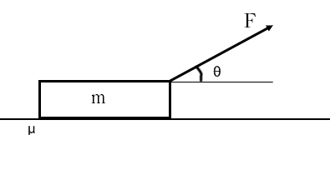

1. Draw a free body diagram and show all the applied forces.
2. How much work is done by force F?
3. How much work is done by the normal force?
4. How much work is done by the gravitational force?
5. How much work is done by the friction force?
6. What is the net work done on the block?
7. What is the change in kinetic energy of the block?
8. A girl pushes a 10.0 kg sled at a constant speed by applying a force of 75.0 N at an angle of 30.0° with respect to the horizontal. The sled is pushed over a distance of 15.0 m.

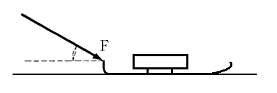

* 1. Draw a free body diagram and show all the applied forces.
  2. How much work is done by force F?
  3. How much work is done by the normal force?
  4. How much work is done by the gravitational force?
  5. How much work is done by the friction force?
  6. What is the coefficient of kinetic friction between the sled and the surface?
  7. How much work is done by the net force on the sled?

1. A 5.0 kg block is released from rest at the top of a quarter-circle type curved frictionless surface. The radius of the curvature is 3.8 m. When the block reaches the bottom of the curvature, it slides on a rough horizontal surface until it comes to rest. The coefficient of kinetic friction between the horizontal surface and the block is 0.020.

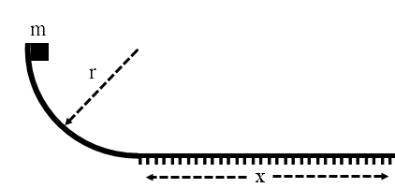

* 1. What is the kinetic energy of the block at the bottom of the curved surface?
  2. What is the speed of the block at the bottom of the curved surface?
  3. Find the stopping distance of the block.
  4. Find the elapsed time of the block while it is moving on the horizontal part of the track.
  5. How much work is done by the friction force on the block on the horizontal part of the track?

1. A spring gun with a spring constant, k, is placed at the edge of a table that is a distance H above the floor and the apparatus is used to shoot marbles with a constant velocity in the horizontal plane. The spring is initially compressed by a distance, X, and then released. The mass of each marble is m.

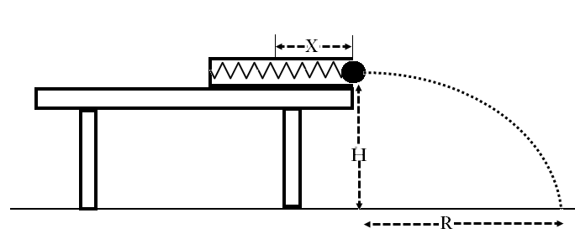

* 1. How much work is done by the spring on the marble?
  2. What is the speed of the marble at the edge of the table (when it leaves the launcher)?
  3. What is the total energy of the marble at the edge of the table with respect to the floor level?
  4. How much time will it take the marble to reach the floor level from the table?
  5. What is the horizontal range of the marble?
  6. What is the kinetic energy of the marble just before it strikes the floor?

1. A 5.0 kg object is initially at rest at x0 = 0. A non-constant force is applied to the object. The applied force as a function of position is shown on the graph below.

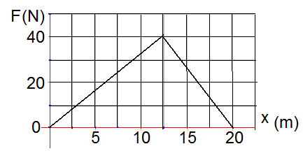

* 1. How much work is done on the object during the first 12.5 m?
  2. What is the change in kinetic energy at the end of 12.5 m?
  3. What is the speed of the object at the end of 12.5 m?
  4. What is the total work done by the force for the entire trip?
  5. What is the change in kinetic energy for the entire trip?
  6. What is the speed of the object at the end of 20 m?

1. A 900.0 kg roller coaster car starts from rest at point A, rolls down the track, goes around a loop (points B and C) and then flies off the inclined part of the track (point D). The dimensions are: H = 80.0 m, r = 15.0 m, h = 10.0 m and θ = 30.0°.

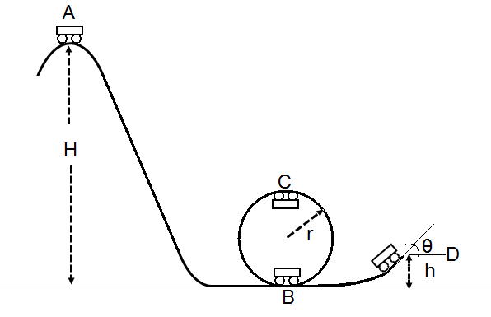

* 1. What is the speed of the car at point B?
  2. What is the speed of the car at point C?
  3. What is the speed of the car at point D?
  4. What is the force applied by the surface of the loop on the car at point B?
  5. What is the force applied by the surface of the loop on the car at point C?
  6. How far (in the horizontal direction) from point D will the car land?

**Answers**

**Chapter Questions**

1. A system is a small segment of the universe that will be used in solving a specific problem, and it will be surrounded by a system boundary. Everything outside this boundary is the environment. Any force outside the boundary will not be considered in solving the system problem.
2. Internal forces do not change the energy of the system. Forces outside the system boundary change the energy of the system.
3. Newton’s Third Law. For every internal force, there is an equal and opposite force. These forces act on different objects, and the work done by one is the negative of the other. So the Work cancels out, and there is no change in energy.
4. Energy is a fundamental quantity of the universe and it is difficult to explain exactly what it is. Energy can be stored; it has the ability to do work; and it can be changed from one form to another (light to thermal, thermal to mechanical, elastic potential energy to kinetic energy).
5. a) Zero work as there is no displacement.

b) Positive, as the force exerted by the person on the box is in the same direction as its displacement.

c) Negative, as the force exerted by the person on the box is in the opposite direction as its displacement.

1. The person is doing positive work on the box as her force is in the same direction as the displacement of the box. The gravitational field is doing negative work on the box as its force (downward) is opposite the direction of the box’s displacement.
2. A closed system is where nothing (energy or mass) crosses the system boundary. An open system permits the transfer of energy or mass across the system boundary. The Conservation of Energy applies only to a closed system.
3. No, energy is either increased (positive work done on the system) or decreased (negative work done on the system).
4. Only the initial and final states of the system need to be considered in solving the problem. Also, energy is a scalar, so there is no vector analysis required. Specifically, problems involving non constant forces or movement in multiple dimensions are much easier to solve using the Conservation of Energy.
5. Trigonometry is used. The force must be resolved into its components along the x and y axes, and only its component in the direction of the displacement is used to calculate the work.
6. The Work-Energy equation was used, and the work done by an external force in lifting an object was calculated. This work increased the energy of the system, and was defined as the GPE. GPE is not an absolute value – it is relative to a chosen reference point as it depends on the displacement from the reference point - Δy.
7. GPE is equal to the negative of the work done by the gravitational field.
8. The total height, h, moved is used in calculating GPE.
9. The force varies as the displacement (compression and expansion) of the spring. Hence, calculus would be needed to solve for the force’s impact on the acceleration. Conservation of Energy is a scalar and depends only on the initial and final states of the spring.
10. The smaller loop. Less energy is transformed into GPE, so more is available for KE which implies a greater speed.
11. The escape velocity is the same for the rocket and the hydrogen atom. Escape velocity depends only on the universal gravitational constant, G, and the mass and radius of the object being escaped from.
12. The kinetic and potential energy of an object escaping a planet (or other celestial body) are assumed to be zero at an infinite distance from the planet (celestial body).
13. P = Fvparallel ; P = (Ef – E0)/Δt

**Chapter Problems**

1. 508 J
2. 37 N
3. 41 J
4. -41 J
5. 0 J
6. 4.90x105 J
7. 6.1 m
8. 2.9x105 J
9. 1.9x104 J
10. 24.3 N
11. 1.78x105 J
12. -1.78x105 J
13. 0 J
14. -3.72x105 J
15. 13.2 m
16. 7.62x105 J
17. 699 J
18. -4.22x103 J
19. 634 J
20. 196 N
21. 314 N; 222 N; 1.32x103 J for both.
22. 201 J
23. -3.35x103 J
24. 1690 J
25. 107 N
26. 206 N; 146 N; 906 J for both.
27. 39 J
28. -4.6 J
29. 1.1 m
30. 0.33 kg
31. 2.5x105J; -2.5x105J; 2.5x105J; 0.0J
32. 340 J
33. -320 J
34. 2.2 m
35. -0.81 J
36. 100 J
37. 5.3 kg
38. 0.26 m
39. 1.7x104J; 1.7x104J; -1.7x104J; 0.0J
40. 3.9x103 J
41. -2.2x103 J
42. 2.3 kg
43. 1.2 m
44. 8.5 m/s
45. 3.5x10-3 J
46. 47 N/m
47. 10 m/s
48. 7.3 m/s
49. 0.65 m
50. 159 N/m
51. 2.7x10-3 J
52. 7.3 m/s
53. 15 m/s
54. 13 m/s
55. 9.4 m/s
56. 0.038 m
57. 15 m/s; the velocities are the same as they are independent of the mass.
58. 15 m/s
59. 13 m/s
60. 4.0 m/s; 3.4 m/s; speed is lower at the top of the bigger loop as more energy goes into GPE, leaving less for KE.
61. -1.20x1012 J
62. -1.13x1012 J
63. 6.82x1010 J
64. The negative sign means that the gravitational force is an attractive force. UG increases as the Barya module moves further away from the Earth.
65. -7.16x1010 J
66. 5.03x103 m/s; since the average velocity of the Nitrogen atom is greater than the escape velocity, the atoms left the atmosphere.
67. 1.04x104 m/s; 1.04x104 m/s; they are the same – escape velocity is mass independent.
68. -4.75x1013 J
69. -8.58x1012 J
70. Earth. ΔUG is greater for the Earth orbit, so more Work needs to be put into the Space Shuttle to get it into orbit, so more fuel is required to generate the thrust.
71. 3.01x1012 J
72. 1.04x104 m/s
73. 1.12x104 m/s
74. 3.37x103 N
75. 7.5 kW
76. 1.3x103 s
77. 3.7 W
78. 190 N
79. 625 kW
80. 49 W
81. 810 s

**General Problems**

1. a.   
     
     
     
     
     
     
     
   b. 1788.94 J  
   c. 0  
   d. 0  
   e. -697.98 J  
   f. 1090.96 J  
   g. 1090.96 J

f

mg

F

1. a.   
     
     
     
     
     
     
     
   b. 974.3 J  
   c. 0  
   d. 0  
   e. -974.3 J  
   f. 0.47  
   g. 0

FN

mg

f

F

1. a. 190 J  
   b. 8.7 m/s  
   c. 190 m  
   d. 43.5 s  
   e. 190 J
2. a. W = KX2   
   b. v = x  
   c. ET = KX2 + mgH  
   d. t =   
   e. r = x  
   f. ET = KX2 + mgH
3. a. 250 J  
   b. 250 J  
   c. 10 m/s  
   d. 400 J  
   e. 400 J  
   f. 12.6 m/s
4. a. 40 m/s  
   b. 31.6 m/s  
   c. 37.4 m/s  
   d. 105, 000 N  
   e. 52, 440 N  
   f. 136 m