***Sound Waves Practice Problems***

*PSI AP Physics 1* Name___________________________________

Multiple Choice

1. Two sound sources S1 and S2 produce waves with frequencies 500 Hz and 250 Hz. When we compare the speed of wave 1 to the speed of wave 2 the result is:
2. Twice as great (B) One-half as great (C) The same

(D) It cannot be determined with the given information.

1. Which of the following is a true statement about the speed of sound in three different materials: air, water, and steel?
2. Vair > Vwater > Vsteel
3. Vair > Vwater = Vsteel
4. Vair < Vwater > Vsteel
5. Vair < Vwater < Vsteel

Use the following picture for questions 3 and 4.

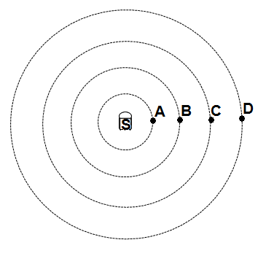

1. A sound source S radiates a sound wave in all directions. The relationship between the distances is SA = AB = BC = CD. Which of the following points oscillates at the highest frequency?
2. Point A (B) Point B (C) Point D

(D) All points have the same frequency

1. A sound source S radiates a sound wave in all directions. The relationship between the distances is SA = AB = BC = CD. Which of the following points oscillates with the greatest intensity?
2. Point A (B) Point B (C) Point D

(D) All points have the same intensity

1. The loudness of a sound wave increases with increasing which of the following:

(A) Frequency (B) Amplitude (C) Wavelength (D) Speed of sound

1. A sound wave travels from air into water. Which of the following doesn’t change?

(A) Frequency (B) Amplitude (C) Wavelength (D) Speed of sound

1. A sound wave resonates in a tube with two open ends. What are the wavelengths of the three lowest resonating frequencies generated in the tube?

(A) L, 2L, 3L

(B) 2L, L, 2L/3

(C) L/2, L/3, L/5

(D) 4L, 4L/3, 4L/5

1. The lowest frequency in an open tube is 300 Hz. What are the three following frequencies will resonate in the tube?

(A) 600Hz, 900Hz, 1200Hz

(B) 100Hz, 200Hz, 400Hz

(C) 150Hz, 450Hz, 850Hz

(D) 50Hz, 100Hz, 150Hz

1. The lowest frequency in an open tube is 200 Hz. Which of the following frequencies will resonate in the tube?

(A) 50Hz (B) 100Hz (C) 250 Hz (D) 400Hz

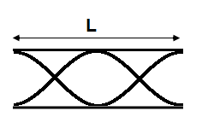

1. A sound wave resonates in an open pipe with a length of 2 m. What is the wavelength of the wave?

(A) 0.5 m (B) 1.0 m (C) 1.5 m (D) 2.0 m



1. A sound wave resonates in an open pipe with a length of 4 m. What is the resonating frequency? (Vsound = 340 m/s)

(A) 85 Hz (B) 170 Hz (C) 340 Hz (D) 510 Hz

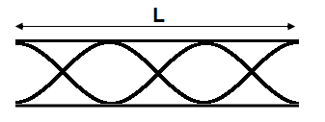

1. A sound wave resonates in an open pipe with a length of 3 m. What is the wavelength of the wave?

(A) 1.5 m (B) 2.0 m (C) 3.0 m (D) 6.0 m



1. A sound wave resonates in an open pipe with a length of 1.5 m. What is the resonating frequency? (Vsound = 340 m/s)

(A) 85 Hz (B) 170 Hz (C) 340 Hz (D) 510 Hz

1. A sound wave resonates in a tube with one open end. What are the wavelengths of the three lowest resonating frequencies generated in the tube?

(A) L, 2L, 3L

(B) L, 2L, 2L/3

(C) L/2, L/3, L/5

(D) 4L, 4L/3, 4L/5

1. The lowest frequency in a closed tube is 300 Hz. What are the three following frequencies will resonate in the tube?

(A) 600Hz, 900Hz, 1200Hz

(B) 100Hz, 200Hz, 400Hz

(C) 250Hz, 500Hz, 750Hz

(D) 900Hz, 1500Hz, 2100Hz

1. The lowest frequency in a closed tube is 400 Hz. Which of the following frequencies will resonate in the tube?

(A) 500Hz (B) 800Hz (C) 1200Hz (D) 2500 Hz

1. Two sound sources generate pure tones of 70 Hz and 80 Hz. What is the beat frequency?

(A) 5Hz (B) 10Hz (C) 15Hz (D) 20Hz

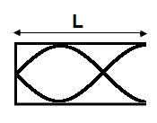

1. A sound wave resonates in a closed pipe with a length of 1.5 m. What is the wavelength of the wave?

(A) 1.5 m (B) 2.0 m (C) 2.5 m (D) 3.0 m

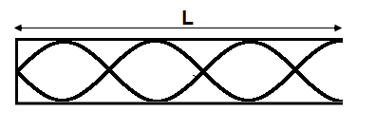

1. A sound wave resonates in a closed pipe with a length of 3.5 m. What is the wavelength of the wave?

(A) 1.5 m (B) 2.0 m (C) 3.0 m (D) 6.0 m

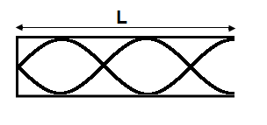

1. A sound wave resonates in a closed pipe with a length of 2.5 m. What is the resonating frequency? (Vsound = 340 m/s)

(A) 85 Hz (B) 170 Hz (C) 340 Hz (D) 680 Hz

1. Two sound sources generate pure tones of 115 Hz and 130 Hz. What is the beat frequency?

(A) 5Hz (B) 10Hz (C) 15Hz (D) 20Hz

1. Two sound sources produce waves with slightly different frequencies. What happens with the beat frequency if the frequency of the lowest tone increases and keeps increasing?

(A) Increases (B) Decreases (C) Increases and then decreases

(D) Decreases and then increases

1. A sound source approaches a stationary observer at a constant speed of 34 m/s. If the frequency of the stationary source is 90 Hz, what is the frequency heard by the observer?

(A) 90 Hz (B) 100 Hz (C) 180 Hz (D) 270 Hz

1. An airplane moves away from a stationary observer at a constant speed of 340 m/s. The frequency of the sound wave of the stationary airplane is 780 Hz. What is the frequency heard by the observer? (Vsound = 340 m/s)

(A) 1560 Hz (B) 780 Hz (C) 390 Hz (D) 195 Hz

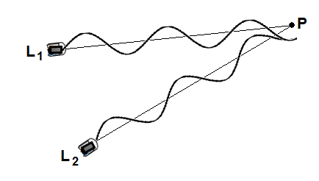

1. Two loudspeakers generate sound waves with frequencies of 680 Hz. What is the extra distance traveled by the second wave if a stationary observer detects maximum intensity of sound at point P?

(A) 0.75 m (B) 1.50 m (C) 1.75 m (D) 2.25 m

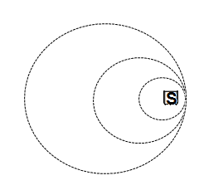

1. A sound source moves at a constant velocity Vobj and generates a sound wave. The speed of sound is Vsound. Which of the following is true about the direction and magnitude of the source velocity?

Direction Magnitude

(A) To the right Vobj > Vsound

(B) To the right Vobj < Vsound

(C) To the right Vobj = Vsound

(D) To the left Vobj = Vsound

1. You are given a hollow tube with an adjustable length and a tuning fork with its frequency printed on it. What measurement would you need to make in order to calculate the speed of sound in that room?
2. The period of the tuning fork.
3. The length of the tube at which that frequency resonates.
4. The temperature in the room.
5. The diameter of the tube.
6. Resonance occurs in a soft drink bottle as air is blown across its top. What property of the resonant sound wave in the bottle remains the same as the level of fluid in the bottle decreases?
7. The speed of the wave
8. The wavelength of the wave
9. The frequency of the wave
10. Nothing remains the same.

Multi-correct Section: For each question or incomplete statement, two of the answers are correct. For each questions you must select both answers.

1. Students are listing to two tones and watching the frequencies on a display as shown below. What can the students conclude from the display? Select two answers.

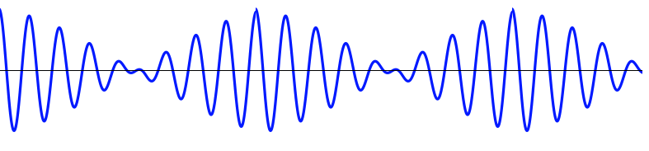

1. The sound waves are traveling in the same direction.
2. The sound waves have different frequencies.
3. The sound waves have the same amplitude.
4. The sound waves are traveling at different speeds.
5. Students are using a speaker to gradually increase the frequency heard. They have one open tube with a length of 0.5m and one closed tube of 0.75m. Which two of the following frequencies will resonate in both tubes?
6. 340Hz
7. 680Hz
8. 1020Hz
9. 1360Hz

Free Response

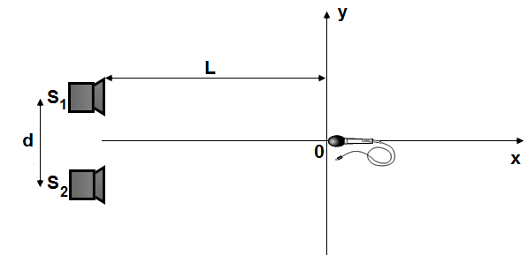

* 1. Two loudspeakers separated by a distance d = 0.5 m are placed at a distance L = 2 m from y-axis. The loudspeakers generate waves with the same frequency f = 1360 Hz and amplitude A. The waves oscillate in phase. When a microphone moves in parallel to y-axis it can detect points with no sound or sound of maximum amplitude. (Vsound = 340 m/s)

1. Determine the wavelength of the sound waves.
2. Determine the angular displacement between the central maximum and first-order maximum.
3. Determine the distance from the origin to the first-order maximum.
4. Determine the distance from the origin to the first point where the microphone detects no sound.
5. If the loudspeakers oscillate in anti-phase, what is the new distribution in the interference pattern?

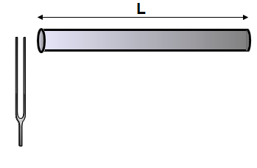

* 1. A group of students in a physics lab perform a series of experiments with a set of tubes and tuning fork. In the first trial they use a tube which length can be extended. The length of the tube when sound resonates for the first time is 0.5 m. (Vsound = 340 m/s)
     1. Determine the wavelength of the sound wave.
     2. Determine the frequency of the tuning fork.

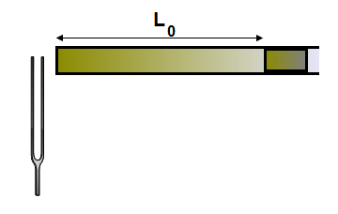

In the second trial the students use a tube with a constant length but they place in the tube a cork stopper with the same diameter as the inner size of the tube. The cork can freely move from the left side of the tube to the right. The frequency of the tuning fork stays the same as it was determine in the first trial.

* + 1. Determine the minimum length L0 of the left side of the tube when the air column resonates for the first time.
    2. What is the length L of the tube when the air column resonates for the second time? third time?

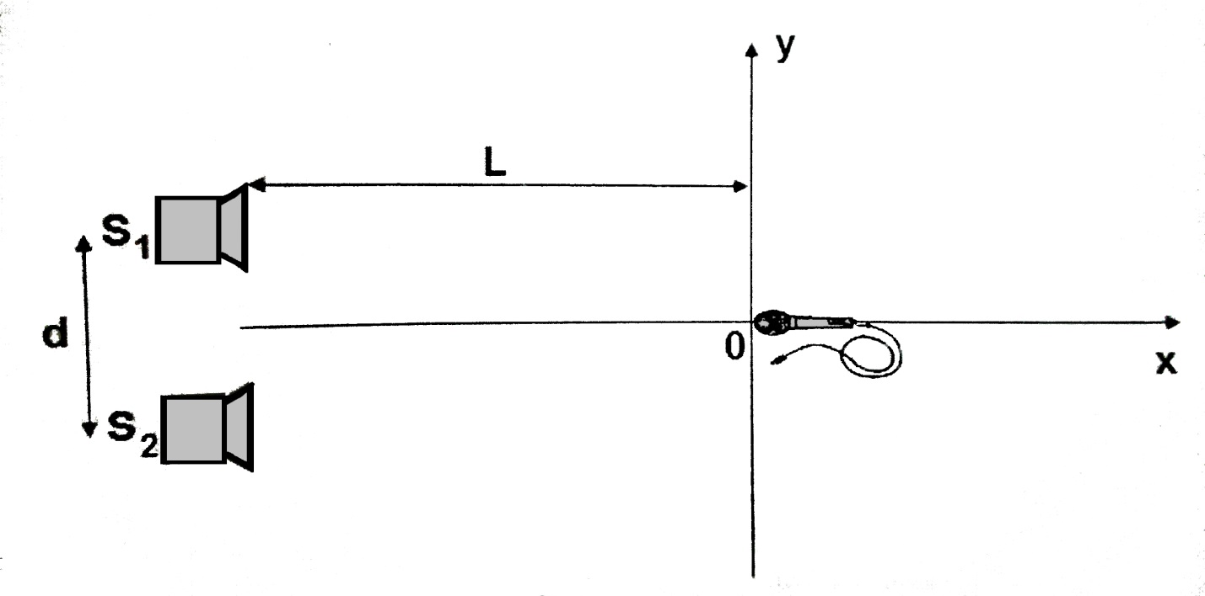

3. Two loudspeakers separated by a distance d = 0.75 m are placed at a distance L = 4 m from the y-axis. The loudspeakers generate waves with the same frequency f = 680 Hz and amplitude A. The waves oscillate in phase. When a microphone moves in parallel to the y-axis, it can detect points with no sound or sound of maximum amplitude. (Vsound = 340 m/s)

1. Determine the wavelength of the sound waves.
2. Determine the angular displacement between the central maximum and first-order maximum.
3. Determine the distance from the origin to the first-order maximum.
4. Determine the distance from the origin to the first point where the microphone detects no sound.
5. If the loudspeakers oscillate in anti-phase, what is the new distribution in the interference pattern?



4. A group of students in a physics lab perform a series of experiments with a set of tubes and tuning forks. In the first trial, they use a tube whose length can be extended. The length of the tube when sound resonates for the first time is 1.0 m. (vsound = 340 m/s)

a. Determine the wavelength of the sound wave.

b. Determine the frequency of the tuning fork.



In the second trial, the students use a tube with a constant length, but they place in the tube a cork     stopper with the same diameter as the inner size of the tube. The cork cn freely move from the left   side of the tube to the right. The frequency of the tuning fork stays the same as it was determined     in the first trial.

c. Determine the minimum length LO of the left side of the tube when the air column resonates for      the first time.

d. What is the length L of the tube when the air column resonates for the second time? Third time?

1. You are in the physics lab with a hollow tube, open at both ends, with an adjustable length. You are also given an adjustable speaker that can produce a single tone at a time. The frequency produced is also shown on the speaker. You are told to use the tube to find the speed of sound in the room.

Describe how you would perform you experiment. Make sure to include what measurements you would make.

Describe how you would use those measurements to calculate the speed of sound.

A student doing a different experiment measures the following periods and wavelengths. Graph the data below to calculate the speed of sound.

|  |  |
| --- | --- |
| Period | Wavelength |
| 0.003s | 1.0m |
| 0.004s | 1.5m |
| 0.005s | 1.7m |
| 0.007s | 2.5m |



1. Two loudspeakers separated by a distance d are placed at a distance L from the y-axis. The loudspeakers generate waves with the same frequency f and amplitude A. The waves oscillate in phase. When a microphone moves in parallel to the y-axis, it can detect points with no sound or sound of maximum amplitude.

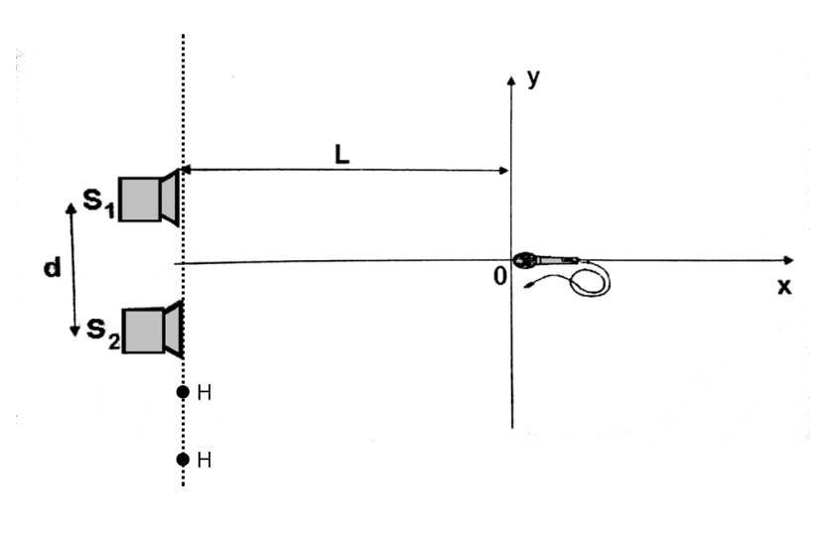

1. Describe how sound intensity I varies as a function of position x along the x-axis from the origin. Sketch the graph of this function on the axes below.

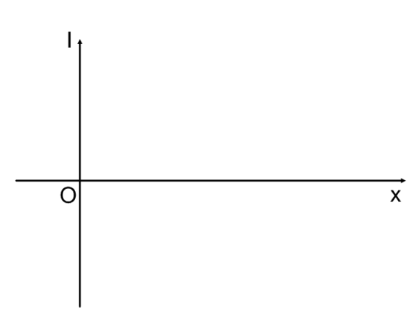

1. On the axis below, sketch a graph of the sound intensity I as a function of position along the y-axis.

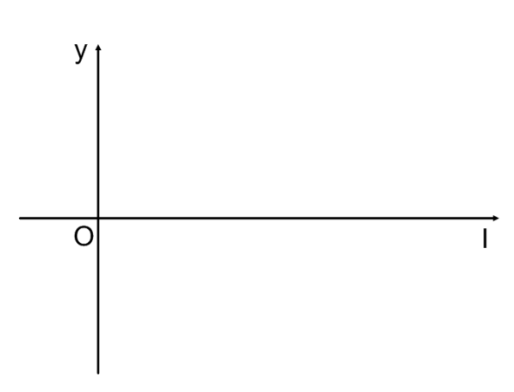

1. Assume that d = 1.5m and the speed of sound is 340m/s. Find the lowest speaker frequency, which will yield the minimum sound intensity along the line HH.

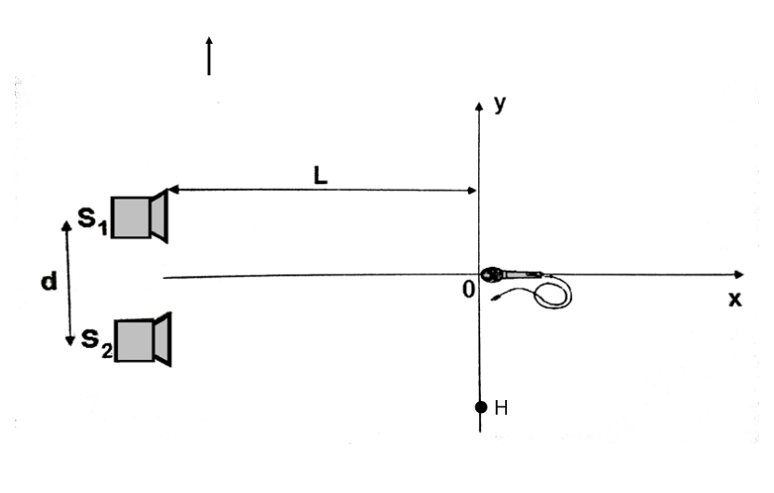

1. Two small speakers *S1 and S2* are positioned a distance of 1m from each other, as shown in the diagram above. The two speakers are each emitting a constant 800Hz tone, and the sound waves from the speakers are in phase with each other. A student is standing at point *O*, which is a distance of 5.0 m from the midpoint between the speakers, and hears a maximum as expected. Assume that reflections from nearby objects are negligible. Use 340 m/s for the speed of sound.
2. Calculate the wavelength of these sound waves.
3. The student moves to point Hand notices that the sound intensity has increased to a maximum. Calculate the shortest distance the student could have moved to hear this maximum.
4. Identify another location on the line that passes through *O* and *P* where the student could stand in order to observe a maximum. Justify your answer.
5. How would your answer to (b) change if the two speakers were moved further apart? Justify your answer.
6. How would your answer to (b) change if the frequency emitted by the two speakers was decreased? Justify your answer.

Answers

MC:

1. C
2. D
3. D
4. A
5. B
6. A
7. B
8. A
9. D
10. D
11. A
12. B
13. C
14. D
15. D
16. C
17. B
18. B
19. B
20. B
21. C
22. D
23. B
24. C
25. B
26. C
27. B
28. A
29. B, C
30. A, C

FR:

1. 0.25m
2. 30°
3. 1.15m
4. 0.52m
5. The pattern will be reversed. Where there used to be maxima there are now minima and vice versa.
6. 1m
7. 340 Hz
8. 0.25m
9. 0.75m, 1.25m
10. 0.5m
11. 41.8o
12. 3.5m
13. 1.4m
14. The pattern will be reversed. Where there used to be maxima there are now minima and vice versa.
15. 2m
16. 170Hz
17. 0.5m
18. 1.5m, 2.5m
19. Increase the frequency (from zero) of the speaker until you hear it resonating (maximum loudness). Record the frequency and measure the length of the tube. Repeat until you find at least 3 more pairs of data.
20. Use the length of the tube to calculate the wavelength with $λ=\frac{2L}{n}$ where n=1. Then use $v=λf$ to find the speed of sound. Since there is more than one set of data, the average can be found.
21. The speed of sound should be approximately 340 m/s.

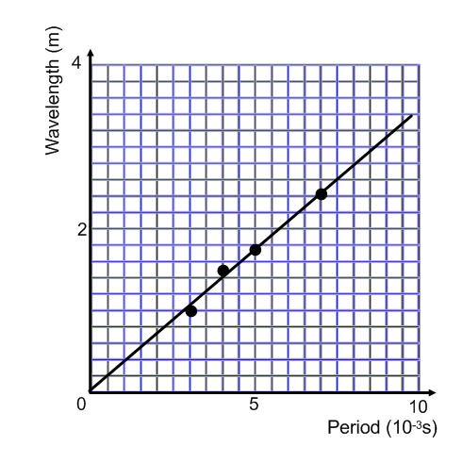

6.

a) 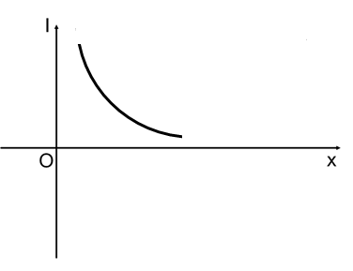

b)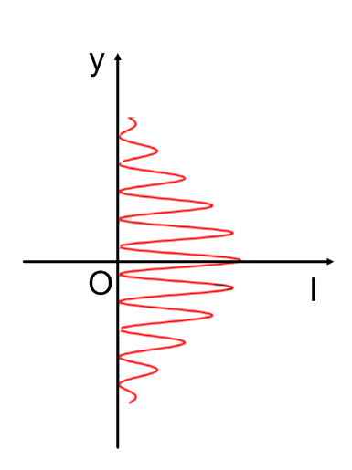

c) 113 Hz

7.

1. 0.425m
2. 2.4m
3. 2.4m on the opposite of the origin or any multiple of 2.4m
4. Y decreases, Y is inversely proportional to the distance between the speakers.
5. Y increases, Y is proportional to wavelength and inversely proportional to frequency.