**PSI AP Physics I**

*Momentum*

Multiple-Choice questions

1. A truck moves along a frictionless level road at a constant speed. The truck is open on top. A large load of gravel is suddenly dumped into the truck. The velocity of the truck:
   1. Increases.
   2. Remains the same.
   3. Decreases.
   4. Immediately goes to zero.
2. A car of mass m is moving with a momentum p. How would you represent its kinetic energy in terms of these two quantities?
   1. p2/2m
   2. ½ p2m
   3. pm
   4. pm/2

1. When a ping-pong ball rolling with a speed of 3.0 m/s collides with a bowling ball at rest, the ping-pong's speed after the collision will be close to:
   1. 0 m/s
   2. 3.0 m/s
   3. 6.0 m/s
   4. 12 m/s

1. A bowling ball moving with speed, v collides head-on with a stationary tennis ball. The collision is elastic, and there is no friction. The bowling ball barely slows down. What is the speed of the tennis ball after the collision?
   1. nearly v
   2. nearly 2v
   3. nearly 3v
   4. nearly 4v
2. A 3 kg ball is dropped onto a concrete floor. What is the magnitude of the ball’s change in momentum if its speed just before striking the floor is 7 m/s and its rebound speed is 3 m/s?
   1. 10 kg-m/s
   2. 15 kg-m/s
   3. 30 kg-m/s
   4. 60 kg-m/s
3. A 3.0 kg toy truck moves freely along a track at 2.0 m/s and collides with a 1.0 kg toy car that is at rest. After the collision, the two cars stick together. What is their velocity after the collision?
   1. 1.5 m/s
   2. 2.0 m/s
   3. 2.5 m/s
   4. 3.0 m/s

Questions 7 - 9

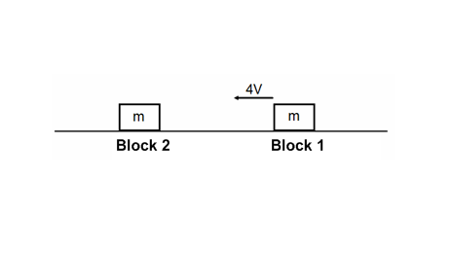

1. Two blocks are on a frictionless surface and have the same mass m. Block 2 is initially at rest. Block 1 moves to the left with speed 4v and collides inelastically with block 2. Which of the following choices is closest to the final speed of the system of two blocks?
   1. zero
   2. v
   3. 2v
   4. 4v
2. Two blocks are on a frictionless surface and have the same mass m. Block 2 is initially at rest. Block 1 moves to the left with speed 4v and collides elastically with block 2. What is the final speed of block 1?
   1. zero
   2. v
   3. 2v
   4. 4v
3. Two blocks are on a frictionless surface and have the same mass m. Block 2 is initially at rest. Block 1 moves to the left with speed 4v and collides elastically with block 2. What is the final speed of block 2?
   1. zero
   2. v
   3. 2v
   4. 4v

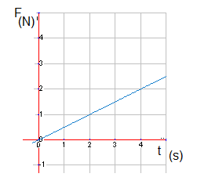

1. An object with a mass of 2.0 kg is accelerated from rest. The above graph shows the magnitude of the net force as a function of time. At t = 4.0 s the object’s velocity is closest to which of the following?
   1. 2.0 m/s
   2. 4.0 m/s
   3. 10 m/s
   4. 13 m/s

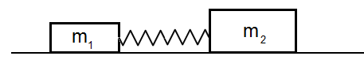

1. A spring is compressed between two blocks with unequal masses, m1 and m2, held together by a spring as shown above. The objects are initially at rest on a horizontal surface with no friction. The spring is then cut. What is true of the two object system after the spring is cut?
   1. The velocities of the two objects are equal in magnitude but opposite in direction.
   2. The kinetic energy of each block is equal and opposite.
   3. The kinetic energy remains the same as before the string was cut.
   4. The net final momentum of the two objects is zero.

Questions 12 – 13

A hockey stick strikes a 0.50 kg puck and is in contact with the puck for t = 0.050 s. The puck travels in a straight line as it approaches and leaves the hockey stick after it is struck. The puck arrives at the stick with a velocity of 6.4 m/s and leaves with a velocity of -3.6 m/s.

1. What is the magnitude of the change in momentum of the puck?
   1. 2 kg-m/s
   2. 3 kg-m/s
   3. 5 kg-m/s
   4. 10 kg-m/s
2. What is the magnitude of the average force acting on the puck?
   1. 100 N
   2. 150 N
   3. 200 N
   4. 300 N
3. A carpenter is initially at rest on an icy pond when he decides to throw his hammer. After being thrown, the hammer moves in one direction while the carpenter moves off in the opposite direction. Which of the following correctly describes this activity?
   1. The carpenter and the hammer will have the same kinetic energy.
   2. The hammer will have a greater magnitude of momentum.
   3. The carpenter will have a greater magnitude of momentum.
   4. The carpenter and the hammer will have equal and opposite momentum.
4. A 40.0 kg physics student at rest on a frictionless rink throws a 3.0 kg box, giving the box a velocity of 8.0 m/s. Which statement describes the initial velocity of the student after the box is thrown?
   1. 0.6 m/s in the same direction as the box.
   2. 0.6 m/s in the opposite direction of the box.
   3. 1.7 m/s in the same direction as the box.
   4. 1.7 m/s in the opposite direction of the box.

Questions 16 – 17

An object of mass 3.0 kg starts from rest and moves along the x–axis. A net horizontal force is applied to the object in the +x direction. The Force-time graph is shown below.

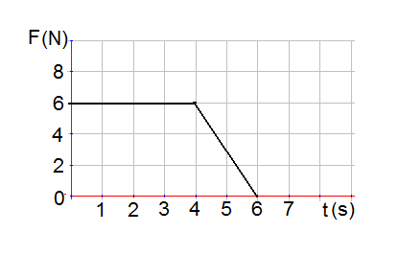

1. What is the net impulse delivered by the applied force?
   1. 6 N-s
   2. 24 N-s
   3. 30 N-s
   4. 36 N-s
2. What is the net work done on the object by the applied force?
   1. 30 J
   2. 50 J
   3. 120 J
   4. 150 J
3. A rubber ball with a mass of 0.25 kg and a speed of 9.0 m/s collides perpendicularly with a wall and bounces off with a speed of 11 m/s in the opposite direction. What is the magnitude of the impulse acting on the rubber ball?
   1. 0.5 kg-m/s
   2. 2 kg-m/s
   3. 5 kg-m/s
   4. 20 kg-m/s
4. A 10,000.0 kg trolley moving at 4.0 m/s collides and couples with a 6000.0 kg trolley which is initially at rest. The final speed of the trolleys is:
   1. 0.5 m/s
   2. 1.0 m/s
   3. 2.0 m/s
   4. 2.5 m/s
5. When the velocity of a moving object is quadrupled, which of the following is also quadrupled?
   1. Kinetic energy
   2. Momentum
   3. Potential energy
   4. Acceleration
6. Two friends with mass 60.0 kg and 40.0 kg run directly toward each other with speeds 3.0 m/s and 2.0 m/s respectively. If they hold on to each other after they collide, their combined speed just after the collision will be:
   1. 0 m/s
   2. 1.0 m/s
   3. 1.6 m/s
   4. 2.0 m/s
7. How long must a 60 N net force act to produce a change in momentum of 240 kg m/s?
   1. 4 s
   2. 3 s
   3. 2 s
   4. 1 s

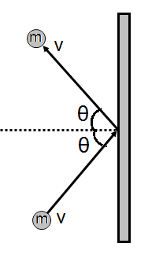

1. As shown above, a tennis ball of mass, m rebounds from a vertical wall with the same speed v as it had initially. What is the change in momentum of the ball?
   1. 2mvsinθ
   2. 2mvcosθ
   3. 2mv
   4. zero
2. Which of the following is true about an object of mass, m1 moving on a horizontal frictionless surface that strikes and sticks to an object of mass m2 (m1>m2)?
   1. The object m1 has greater momentum after the collision than before the collision.
   2. The object m2 has greater momentum after the collision then before the collision.
   3. Momentum is conserved during the collision.
   4. Kinetic energy is conserved during the collision.

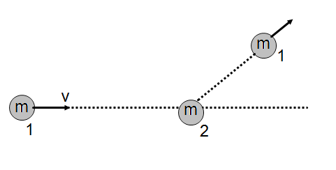

1. A steel ball (1) moving at a constant speed, v on a horizontal frictionless surface, collides obliquely with an identical ball (2) initially at rest. The velocity of the first ball before and after the collision is shown on the diagram above. What is the approximate direction of the velocity of the second ball after the collision?
2. 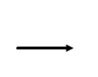 B.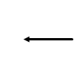 C. 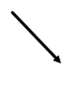 D. 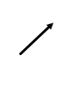

Questions 26 – 27

A stationary cannon ball explodes in three pieces of masses m, m and 2m. The momentum of the equal masses (m1 and m2) is shown in the diagram below.

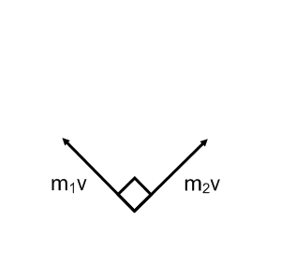

1. What is the direction of the momentum of the 2m mass?

A. 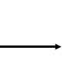 B. 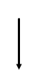 C.  D. 

1. What is the magnitude of the velocity of the 2m cannon ball piece?
$\frac{\sqrt{7}}{2}v$

$\frac{\sqrt{5}}{2}v$

$\frac{\sqrt{3}}{2}v$

$\frac{\sqrt{2}}{2}v$

2. An object with an initial momentum shown above collides with another object at rest. Which of the following combinations of two vectors may represent the momentum of the two objects after the collision?
3. 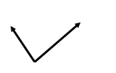 (B) 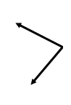 (C) 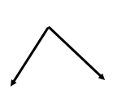D. 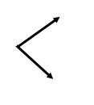

Questions 29 – 30

A 6 kg block moves with a constant speed 5 m/s on a horizontal frictionless surface and collides elastically with an identical block initially at rest. The second block collides and sticks to the last 6 kg block which was initially at rest.

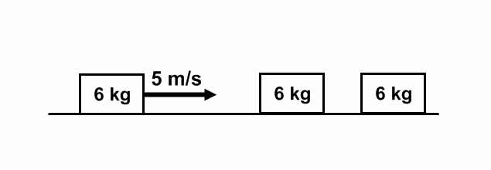

1. What is the speed of the second 6 kg block after the first collision?
   1. zero
   2. 2 m/s
   3. 2.5 m/s
   4. 5 m/s
2. What is the speed of the third 6 kg block after the second collision?
   1. zero
   2. 2 m/s
   3. 2.5 m/s
   4. 5 m/s

Questions 31-32

Object A with a mass of 8.0 kg travels to the east at 10.0 m/s and object B with a of mass 3.0 kg travels south at 20.0 m/s. The two objects collide and stick together.

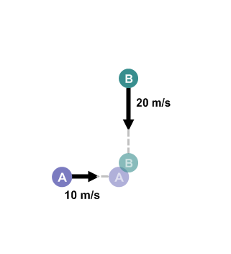

1. What is the magnitude of the object’s combined velocity after the collision?
   1. 1.8 m/s
   2. 9.1 m/s
   3. 13 m/s
   4. 25 m/s
2. What is the direction of the velocity after the collision?
   1. 300 south of east
   2. 370 south of east
   3. 450 south of east
   4. 530 south of east

**Multi Correct Questions:** For each of the questions or incomplete statements below, two of the suggested answers will be correct. For each of these questions, you must select both correct choices to earn credit. No partial credit will be earned if only one correct choice is selected. Select the two that are best in each case.

1. A steel ball and a piece of clay have equal masses. They are dropped from the same height on a horizontal steel platform. The ball bounces back with nearly the same speed with which it hit. The clay sticks to the platform. Which is true about the ball/platform and the clay/platform systems?
   1. The ball has a greater momentum change.
   2. The clay has a greater momentum change.
   3. The momentum of each system changes.
   4. The momentum of each system stays the same.
2. A kickball is rolled by the pitcher at a speed of 10 m/s and it is kicked by another student. The kickball deforms a little during the kick, and then rebounds with a velocity of 15 m/s as its shape restores to a perfect sphere. What must be true about the kickball and the kicking foot system?
   1. The kinetic energy of the system before and after the kick is the same.
   2. The kinetic energy of the system before and after the kick is not the same.
   3. The momentum of the system before and after the kick is the same.
   4. The momentum of the system before and after the kick is not the same.
3. A karate master is about to split a piece of wood with his hand. In order to deliver the maximum force to split the wood, she will:
   1. Strike the wood perpendicular to its surface with as much force as possible.
   2. Strike the wood and snap her hand back as quickly as possible.
   3. Strike the wood and not attempt to snap her hand back.
   4. Strike the wood at an angle to the normal with as much force as possible.
4. Two astronauts are in the space shuttle, floating next to each other. One astronaut pushes on the other, sending him across the shuttle bay. The first astronaut doesn’t move. Which physics laws were violated in this scenario?
   1. Conservation of Energy.
   2. Newton’s First Law.
   3. Conservation of Momentum.
   4. Newton’s Third Law.
5. A fisherman is standing in the back of his small fishing boat (the mass of the fisherman is the same as the mass of the boat) and he is a few meters from shore. He is tired of fishing so he starts walking towards the shore so he can get off the boat. What happens to the boat and the fisherman? Assume there is no friction between the boat and the water.
   1. The fisherman gets closer to the shore.
   2. The fisherman gets further away from the shore.
   3. The center of mass of the boat/fisherman system moves towards the shore.
   4. The center of mass of the boat/fisherman system does not move.
6. Two lab carts are on a frictionless track, attached by a spring. The carts are pushed together by a student in a Physics lab, compressing the spring fully. The student lets go of the carts and they move in opposite directions as the spring extends. Which of the following statements describes what happens to the car/spring system after the cars are released?
   1. The kinetic energy remains constant.
   2. The kinetic energy increases.
   3. The momentum remains constant.
   4. The momentum increases.

Multiple Choice Answer Key

* + - 1. C
      2. A
      3. B
      4. B
      5. C
      6. A
      7. C
      8. A
      9. D
      10. A
      11. D
      12. C
      13. A
      14. D
      15. B
      16. C
      17. D
      18. C
      19. D
      20. B
      21. B
      22. A
      23. B
      24. C
      25. C
      26. B
      27. D
      28. D
      29. D
      30. C
      31. B
      32. B
      33. A, D
      34. B, C
      35. A, B
      36. C, D
      37. A, D
      38. B, C