***Electric Force and Electric Field Practice Problems***

*PSI AP Physics 1* Name___________________________________

Multiple Choice

1. A plastic rod is rubbed with a piece of wool. During the process the plastic rod acquires a negative charge and the wool:

(A) acquires an equal positive charge

(B) acquires an equal negative charge

(C) acquires less in magnitude positive charge

(D) acquires less in magnitude negative charge

1. A positively charged sphere is brought near one end of an uncharged metal bar. The end A and B of the metal bar will be charged:

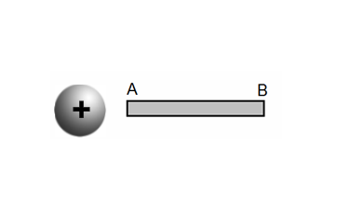

(A) positive, negative

(B) negative, positive

(C) positive, positive

(D) negative, negative

1. 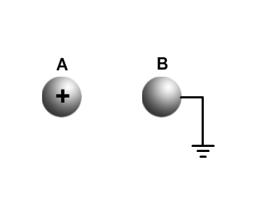Sphere A carries a net positive charge, and sphere B is neutral. They are placed near each other on an insulated table. Sphere B is briefly touched with a wire that is grounded. Which statement is correct?

(A) sphere B remains neutral

(B) sphere B is now positively charged

(C) sphere B is now negatively charged

(D) sphere B is now positive and sphere A is negative

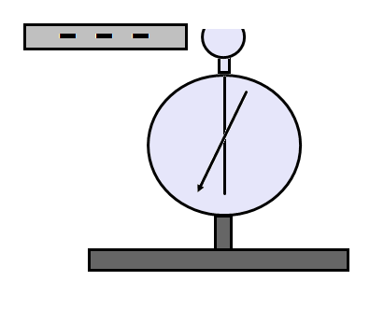

1. An originally neutral electroscope is briefly touched with a negatively charged plastic rod. Which statement is correct?

(A) electroscope remains neutral

(B) electroscope becomes negatively charged

(C) electroscope becomes positively charged.

(D) electroscope becomes negatively charged and rod becomes positively charged

Questions 5-6

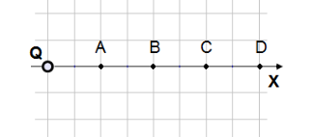

1. An electric charge Q is placed at the origin. A charge q is placed at point B and the force on charge q due to charge Q is F. What is the force on charge q if charge q is moved to point A?

(A) 4F (B) 2F (C) F/4 (D) F/2

1. An electric charge Q is placed at the origin. A charge q is placed at point A and the force on charge q due to charge Q is F. What is the force on charge q if charge q is moved to point C?

(A) 9F (B) 3F (C) F/3 (D) F/9

1. A student in a physics lab wants to determine the type of an electric charge on initially charged electroscope. He brings two charged rods without touching the electroscope. The positively charged rod causes the leaves to move further apart and the negatively rod causes leaves to move closer to each other. What type of the electric charge was initially on the electroscope?

1. positive (B) negative (C) neutral

(D) couldn’t be determine because the electroscope wasn’t grounded

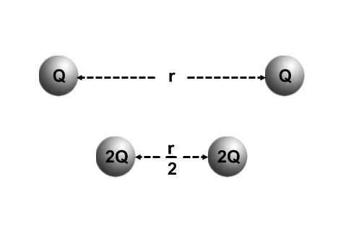

1. Two charged objects with an equal charge of Q separated by a distance r attract each other with a certain force. If the charges on both objects are doubled and the separation is halved, the force between them is:

(A) 4 times greater (B) 2 times greater

(C) 4 times less (D) 16 times greater

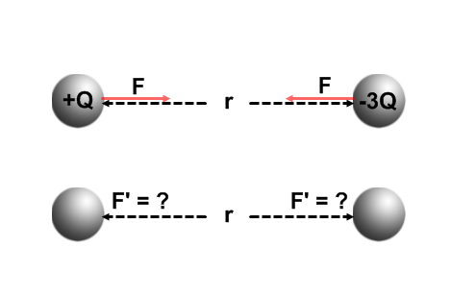

1. Two identical conducting spheres are charged to +Q and -3Q and separated by a distance r. The attractive force between the spheres is F. The two spheres are brought in a brief contact and then moved to the original positions. If the new electrostatic force between the spheres is F’, which of the following is true?
2. F’ = F (B) F’ = 3F (C) F’ = 1/3 F (D) F’ = 9F

Questions 10-11

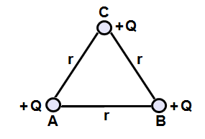

Three positive charges with an equal charge of Q are located at the corners of an equilateral triangle of side r.

1. What is the direction of the net force on charge C due to charges A and B?

(A) 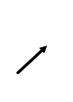 (B) (C)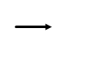 (D) 

1. What is the magnitude of the net force on charge C due to two charges A and B?



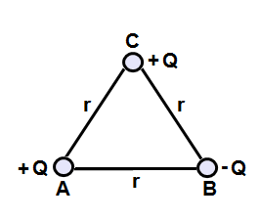 Questions 12-13

Three equal in magnitude charges are located at the corners of an equilateral triangle of side r. The charges A and C are positive and charge B is negative.

1. What is the direction of the net force on charge C due to charges A and B?

(A)  (B) (C) (D) 

1. What is the magnitude of the net force on charge C due to charges A and B?



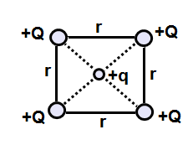

1. Four positive Q charges are arranged in the corner of a square as shown on the diagram. What is the direction of the net force on the test charge q placed at the center of the square?

(A)  (B) (C) (D) the net force is zero

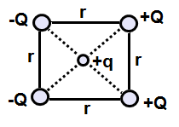

1. Four Q charges are arranged in the corner of a square as shown on the diagram. What is the direction of the net force on the test charge q placed at the center of the square?
2.  (B) (C) (D) 



1. Four Q charges are arranged in the corner of a square as shown on the diagram. What is the magnitude of the net force on the test charge q placed at the center of the square?

1.  (B)  (C)  (D) 

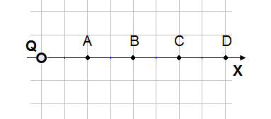

1. An electric charge Q is placed at the origin. If the magnitude of the electric field at point A is E, what is the electric field at point B?
2. 4E (B) 2E (C) E/4 (D) E/2

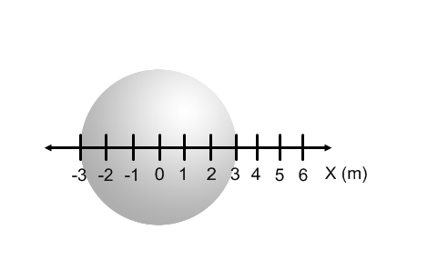

1. A conducting sphere is charged with a negative charge –Q. Which statement about the charge distribution is correct?
2. Charge is concentrated at the center of the sphere
3. Charge is concentrated at the bottom part of the sphere
4. Charge is evenly distributed throughout the volume of the sphere
5. Charge is evenly distributed on the surface of the sphere
6. The conducting sphere shown above is charged with a negative charge –Q. Which statement about the magnitude electric field of the sphere is correct?

1. Maximum at the center (B) Maximum at point 1 m (C) Maximum at point 3 m

(D) Maximum at point 4 m

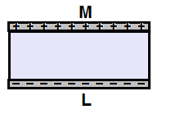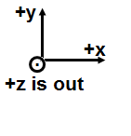

1. Two parallel conducting plates are charged with an equal and opposite charges. Which statement is true about the direction of the electric field?
2. Directed in +X (B) Directed +Y (C) Directed in -X (D) Directed in -Y

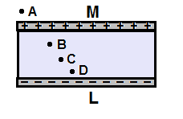

1. Two parallel conducting plates are charged with an equal and opposite charges. Which statement is true about the magnitude of the electric field?
2. Greater at point A (B) Greater at point B (C) Greater at point C

(D) The same at points B, C, D and zero at point A

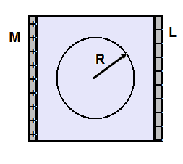

1. A conducting sphere with a radius R is placed in a uniform electric field produced by two parallel plates M and L. Which statement is true about the electric field inside the sphere?
2. Increasing from the center to the surface
3. Decreasing from the center to the surface
4. Increasing from the left to the right across the sphere
5. Is zero everywhere inside the sphere

Questions 23‑24

An electron with a charge e and mass m is accelerated from rest for a time T by a uniform electric field that exerts a force F on the electron.

1. What is the magnitude of the electric field?

(A) eF (B) F/m (C) F/e (D) em/F

1. The speed of the electron after it has accelerated for the time T is most nearly   
   (A) eT/m (B) FT/m (C) emT/F (D) FT/em
2. Two isolated charges, + 2q and ‑5q, are 2 centimeters apart. If F is the magnitude of the force acting on charge ‑5Q, what are the magnitude and direction of the force acting on charge + 2q ?

Magnitude Direction  
(A) (1/2) F Toward charge ‑5q  
(B) 2 F Away from charge ‑5q  
(C) F Toward charge ‑5q  
(D) F Away from charge ‑5q

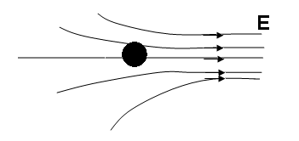

1. Which of the following is true about the net force on an uncharged conducting sphere in a non-uniform electric field?

(A) It is zero

(B) It is in the direction of the field

(C) It is in the direction opposite to the field

(D) It produces a torque on the sphere about the direction of the field

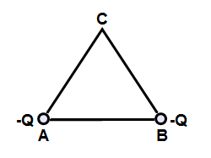

1. Two negative charges A and B are placed at the corners of equilateral triangle. What is the direction of the net electric field at point C?

(A) (B) (C) (D) 



1. Two negative charges A and B are placed at the corners of equilateral triangle. What is the magnitude of the net electric field at point C?
2.  (B)  (C)  (D) 

Questions 29-30

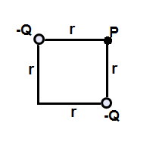

The figure above shows two particles, each with a charge of -*Q*, that are located at the opposite corners of a square of side *d*.

1. What is the direction of the net electric field at point P?

(A)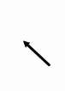 (B)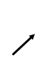 (C)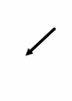 (D) 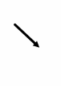

1. What is the net electric field at point P?

(A)  (B)  (C)  (D) 

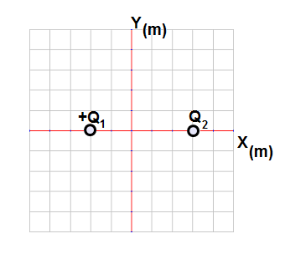

1. A point charge Q1 = +4.0 µC is placed at point -2 m. A second charge Q2 is placed at point +3 m. The net electric field at the origin is zero. What is charge Q2?

Magnitude Sign

1. 9.0 µC (A) Positive
2. 6.0 µC (B) Positive
3. 3.0 µC (C) Positive
4. 9.0 µC (D) Negative

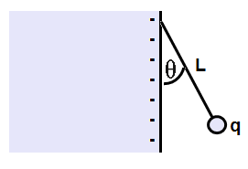

1. A small sphere with charge q and mass m is attached to one end of an insulating string of length L. The other end is attached to negatively charged wall. The electric field E due to the charged wall is constant in the vicinity of the charged sphere. The string makes a constant angle ϴ with the vertical. What is the sign and magnitude of charge q?
2. Positive and magnitude 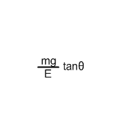
3. Positive and magnitude 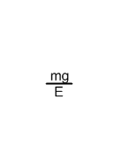

1. Negative and magnitude 
2. Negative and magnitude 

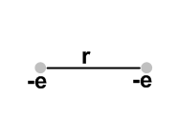Multi-correct Section: For each question or incomplete statement, two of the answers are correct. For each questions you must select both answers.

1. Two electrons are separated by a distance r. Which of the following statements is correct?
2. There is an attractive electrostatic force between the electrons
3. There is a repulsive electrostatic force between the electrons
4. The gravitational force between the electrons much greater than electrostatic force
5. The electrostatic force is much greater that gravitational force

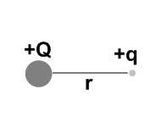

1. A positively charged sphere of charge +Q is held stationary. A small test charge +q is placed near the sphere and released from rest. The test charge will move away from the sphere with
2. Increasing acceleration
3. Decreasing acceleration
4. Increasing velocity
5. Decreasing velocity
6. Which of the following statement is true about a positively charge conductor?
7. The electric field inside increases linearly from the center
8. The electric field inside is zero
9. The electric field lines are parallel to the surface of the conductor
10. The electric filed lines are perpendicular to the surface of the conductor

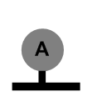

1. A neutral conducting sphere A is placed on an insulating table. Which of the following will cause the sphere to gain positive charge?
2. Touch the sphere with a negatively charged rod
3. Touch the sphere with a positively charged rod
4. Bring a negatively charged rod near the sphere and briefly touch the sphere with a grounding wire
5. Bring a positively charged rod near the sphere and briefly touch the sphere with a grounding wire

**Chapter Questions**

**Electric Charge**

**Classwork**

1. What happens to a plastic rod when it is rubbed with a piece of animal fur? What happens to the piece of fur?
2. How many types of electric charge are there? What are they named?
3. How can you tell when two objects, after being rubbed together, have each acquired an electric charge? How will the magnitude of the charge on each compare with one another? How about the sign of the charge on each?
4. What happens when two glass rods are rubbed with silk and they are brought close to each other?

**Homework**

1. What happens between a plastic rod rubbed with a piece of animal fur and a glass rod rubbed with a piece of silk when they are brought close to each other?
2. What happens when two glass rods are rubbed with silk and they are brought close to each other?
3. Who assigned the convention of the charge remaining on a glass rod after being rubbed by silk as negative?

**Atomic Structure and Source of Charge**

**Classwork**

1. Which particle of an atom carries a positive charge? Which carries the negative charge?
2. When a neutral atom captures a free electron, what is the net charge on the atom? What do we call this type of atom?
3. What is most of the atom composed of?
4. Is it possible to add 0.5e of charge to an object? Explain.

**Homework**

1. Eight electrons orbit a neutral oxygen atom. How many protons are in the nucleus?
2. When an electron is removed from a neutral atom, what is the net charge on the atom? What is this type of atom called?
3. A glass rod obtains a positive charge after being rubbed by silk. Is this due to the glass gaining protons, or losing electrons? Explain.
4. Describe two ways that you can give an electroscope a positive charge.

**Conduction and Induction; Electroscope**

**Classwork**

1. A student has a positively charged glass rod but she wants to charge an electroscope negatively. What should she do to accomplish that? Why does that work?
2. A student brings a negatively charged plastic rod near a tiny piece of paper that is resting on a tabletop. Will the paper be attracted or repelled? Explain why.
3. Why is it that when you take off a sweater in a dark room you can see tiny sparks and hear a crackling sound?

**Homework**

1. A positively charged rod attracts a metal ball suspended at the end on an insulating string. Explain the mechanism of attraction.
2. An electroscope (insulated from ground) is charged negatively and a charged rod is brought very close but does not touch the electroscope. As a result the leaves move further apart. What kind of electric charge is on the rod?
3. Two light paper strips are suspended at the ends of two insulating strings, and are far apart from each other. One paper strip is charged and the other is not charged. Design an experiment to determine which strip is charged.
4. A student touches an electroscope with his hand at the same time he brings a positively charged rod close to the electroscope without touching. When he removes his hand first and then moves the rod away from the electroscope the leaves move apart. Why? What type of charge is on the leaves?

**Electric Force (Coulomb’s Law)**

**Classwork**

1. Will two charged objects interact on the Moon, where there is no atmosphere?
2. If the distance between two charged objects is doubled, what happens to the electrical force between them?
3. When performing calculations using Coulomb’s Law, why is the force of gravity usually neglected?

**Homework**

1. Two charges repel each other with a force of F0. One of the charges is replaced with another charge that is three times its magnitude. What is the new force between these charges in terms of F0?
2. Compare and contrast Coulomb’s Law with Newton’s Law of Universal Gravitation.
3. Does the mass of a charged object affect the electrical force between it and another charged object?

**Electric Field**

**Classwork**

1. What is the definition of the Electric Field and what equation was used to derive this concept?
2. Why can Electric Field lines never cross or touch each other? Do Electric Field lines exist?
3. Draw the electric field lines around a positive charge. How would these lines be different if the charge was negative?
4. What is the significance of the density of the electric field lines about a charge?

**Homework**

1. Compare and contrast the Gravitational Field and the Electric Field.
2. What is the dominant field that acts on two electrons that are 10-12 m apart? Gravitational or Electric Field?
3. How is the Electric Field due to several charges calculated?

**Chapter Problems**

**Coulomb’s Law**

**Classwork (**Use k = 9x109 Nm2/C2)

1. Two positive charges of 1 mC and 10 mC are separated by a distance of 10 m. Find the direction and the magnitude of electrostatic force between the charges. Describe the direction in terms of “the charges attract each other,” or “the charges repel each other.”
2. A particle with a charge of +7.4 μC is separated from another charged particle with a charge of –3.6 μC by a distance of 1.4 m. Find the direction and the magnitude of electrostatic force between the particles.
3. A +1.4 nC charge exerts a repulsive force of 20.0 mN on a second charge which is located a distance of 2.2 m away from it. What is the magnitude and sign of the second charge?
4. Two spherical objects, whose centers are 8.0 cm apart, have equal negative charges and repel each other with a force of 9.0 mN. What is the charge on each of them? How many extra electrons are on each of them?
5. Two conducting spheres have net charges of +9.00 μC and -7.00 μC and attract each other with a force of 4.00 mN. The spheres are brought in contact and then moved apart to the initial distance. What is the new force between the spheres? Is this force attractive or repulsive?

**Homework**

1. Two negative charges of 2.5 μC and 9.0 μC are separated by a distance of 25 cm. Find the direction (in terms of repulsive or attractive) and the magnitude of the electrostatic force between the charges.
2. Two charges of +2.6 μC and –5.4 μC experience an attractive force of 6.5 mN. What is the separation between the charges?
3. What is the distance between two charges, +7.8 μC and +9.2 μC, if they exert a force of 4.5 mN on each other?
4. A –4.2 μC charge exerts an attractive force of 1.8 mN on a second charge which is a distance of 2.4 m away. What is the magnitude and sign of the second charge?
5. Two equal negative point charges repel each other with a force of 18.0 mN. What is the charge on each object if the distance between them is 9.00 cm? How many extra electrons are on each object?
6. Two charged conducting spheres have net charges of +4.0 μC and -8.0 μC and attract each other with a force of 16 mN. The spheres are brought into contact and then moved apart to the initial distance. What is the new force between the spheres? Is this force attractive or repulsive?
7. What is the ratio of the electrostatic force to the gravitational force between two electrons?
8. **Electric Field**

**Classwork**

1. A 2.40 μC charge is subject to a 3.00 mN force due to an Electric Field. What is the magnitude of the Electric Field at the location of the charge?
2. A 6.3 μC electric charge is placed in an Electric Field with a magnitude of 5.0 x 105 N/C. What is the electric force on the charge due to the Electric Field?
3. A 5.6 nC electric charge is placed in an Electric Field and experiences a force of 7.4 μN. What is the magnitude of the Electric Field at that location?

**Homework**

1. What is the direction and magnitude of the Electric Field due to a -6.8 μC point charge at a distance of 7.4 m?
2. An oil drop is charged negatively. How much charge is on the drop if the Electric Field is 6,400 N/C at a distance of 1.2 m?
3. What is the direction and magnitude of the Electric Field 4.0 m away from an 8.6 μC charge?
4. The Electric Field due to a charged particle is 3,600 N/C at a location 2.4 m away from the particle. How much electric charge is on the particle?

**Electric Field relationship to Gravitational Field**

**Classwork**

1. Calculate and compare the gravitational force and the electrical force between two protons that are separated by 1.2 x 10-15 m (G = 6.67 x 10-11 Nm2/kg2, e = 1.60 x 10-19 C, mp = 1.67 x 10-27 kg).
2. Calculate and compare the gravitational force and the electrical force between two electrons that are separated by 4.15 x 10-12 m (G = 6.67 x 10-11 Nm2/kg2, e = 1.60 x 10-19 C, me = 9.11 x 10-31 kg).
3. What is the magnitude of the Electric Field required to “levitate” an electron in the Earth’s gravitational field.

**Homework**

1. Calculate and compare the gravitational force and the electrical force between two protons that are separated by 4.25x 10-15 m (G = 6.67 x 10-11 Nm2/kg2, e = 1.60 x 10-19 C, mp = 1.67 x 10-27 kg).
2. Calculate and compare the gravitational force and the electrical force between two electrons that are separated by 9.45 x 10-12 m (G = 6.67 x 10-11 Nm2/kg2, e = 1.60 x 10-19 C, me = 9.11 x 10-31 kg).
3. What is the magnitude of the Electric Field required to suspend an oil drop of mass 1.0 x 10-4 kg with a charge of 6.2 x 10-6 C in the Earth’s gravitational field?

## **Electric Field of Multiple Charges**

## **Classwork**

1. Draw the Electric Field line surrounding one single positive charge.
2. Draw the Electric Field lines surrounding two positive electric charges that are in a horizontal line, separated by a distance, r.
3. Draw the Electric Field lines surrounding a positive charge on the top and a negative charge below.

**Homework**

1. Draw the Electric Field line surrounding one single negative charge.
2. Draw the Electric Field lines surrounding two negative electric charges that are in a horizontal line, separated by a distance, r.
3. Draw the Electric Field lines surrounding a negative charge on the left and a positive charge on the right.

## **The Net Electric Field**

## **Classwork**

+Q1  +Q2

-3 -2 -1 0 1 2 3 4 5 6 7 8 **x(m)**

1. As shown in the above diagram, a positive charge, Q1 = 2.6 μC, is located at a point, x1 = -3.0 m, and a positive charge, Q2 = 1.4 μC, is located at a point, x2 = +4.0 m.
2. Find the magnitude and direction of the Electric Field at the origin due to charge Q1.
3. Find the magnitude and direction of the Electric Field at the origin due to charge Q2.
4. Find the magnitude and direction of the net Electric Field at the origin.

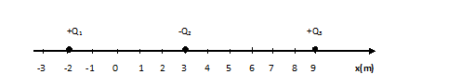

1. A positive charge, Q1 = 7.4 μC, is located at x1 = -2.0 m, a negative charge Q2 = -9.7 μC is located at a point x2 = 3.0 m and a positive charge Q3 = 2.1 μC is located at a point x3 = 9.0 m.
2. Find the magnitude and direction of the Electric Field at the origin due to Q1.
3. Find the magnitude and direction of the Electric Field at the origin due to Q2.
4. Find the magnitude and direction of the Electric Field at the origin due to Q3.
5. Find the magnitude and direction of the net Electric Field at the origin.

**Homework**

-Q1  +Q2

-3 -2 -1 0 1 2 3 4 5 6 7 8 **x(m)**

1. As shown in the above diagram, a charge, Q1 = -3.6 μC, is located at a point, x1 = -2.0 m, and a positive charge, Q2 = 2.8 μC, is located at a point, x2 = +6.0 m.
2. Find the magnitude and direction of the Electric Field at the origin due to charge Q1.
3. Find the magnitude and direction of the Electric Field at the origin due to charge Q2.
4. Find the magnitude and direction of the net Electric Field at the origin.

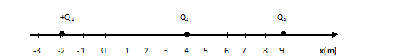

1. A positive charge, Q1 = 5.2 μC, is located at x1 = -2.0 m, a negative charge Q2 = -9.7 μC is located at a

point x2 = 4.0 m and a negative charge Q3 = -4.1 μC is located at a point x3 = 9.0 m.

1. Find the magnitude and direction of the Electric Field at the origin due to Q1.
2. Find the magnitude and direction of the Electric Field at the origin due to Q2.
3. Find the magnitude and direction of the Electric Field at the origin due to Q3.
4. Find the magnitude and direction of the net Electric Field at the origin.

Free Response Problems

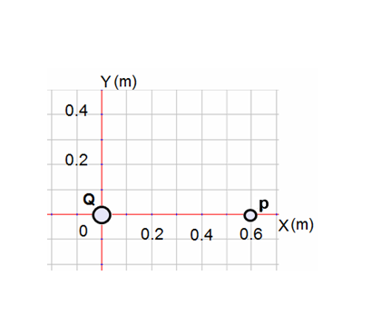

1. Sphere 1 carries a positive charge Q = +6 µC and located at the origin.
2. What is the direction of the electric field at point P 0.6 m away from the origin?
3. What is the magnitude of the electric field at point P?

A test charge q = +1 µC and mass m = 2.5 g is brought from infinity and placed at point P

1. What is the direction of the electric force on charge q due to charge Q?
2. What is the magnitude of the electric force on charge q due to charge Q?
3. What is the acceleration of charge q at the instant when it is released from point P?
4. 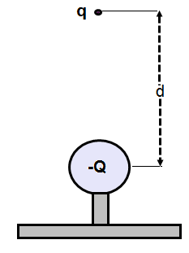A negatively charged sphere with charge Q = -20 µC is placed on an insulating table a tiny charge q and mass of m = 3.6 g is suspended at rest above charge Q. The distance between the charges is 0.8 m.
5. What is the direction of the electric field due to charge Q at the distance d above charge Q?
6. What is the magnitude of the electric field due to charge Q at the distance d above charge Q?
7. On the diagram below show all the forces applied on charge q.



1. What should be the sign and magnitude of the charge q in order to keep it at equilibrium?

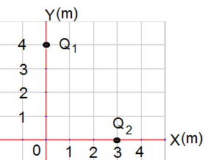

1. A charge Q1 = -32 µC is fixed on the y axis at y = 4 m, and a charge Q2 = +18 µC is fixed on the x axis at x = 3 m.
2. Calculate the magnitude of the electric field E1 at the origin due to charge Q1.
3. Calculate the magnitude of the electric field E2 at the origin due to charge Q2.

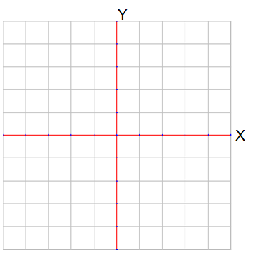

1. On the diagram below, draw and label the electric fields E1, E2 and the net electric field at the origin.
2. Calculate the net electric field at the origin due to two charges Q1 and Q2.



1. A wall has a negative charge distribution producing a uniform field. A small dielectric sphere of mass 10 g and charge of -90 µC is attached to one end of insulating string 0.6 m long. The other end of the string is attached to the wall. The uniform electric field has a magnitude of 500 N/C.
2. What is the direction of the uniform electric field?
3. What is the direction and magnitude of the electric field on charge q due to uniform electric filed?
4. On the diagram below draw and label all the applied forces on charge q.



1. Calculate the angle ϴ between the wall and the string.
2. Calculate the shortest distance between the wall and charged sphere.
3. The string is cut:
4. Calculate the magnitude of the net acceleration of the charged sphere q.
5. Describe the resulting path of the charged sphere.

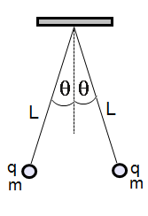

1. Two small spheres with masses m1 = m2 = m = 25 g are hung by two silk threads of length L = 1.8 m from a common point. The spheres are charged with equal charges q1 = q2 = q, each thread makes an angle ϴ = 25 ̊ with the vertical line.
2. On the diagram below draw and label all the applied forces on each sphere.

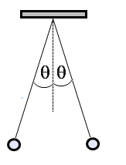

1. Calculate the distance between the spheres.
2. Calculate the magnitude of the electric force between the spheres.
3. Calculate the magnitude of the charge on spheres.

Some of the electric charge has left the spheres due to humidity in the room. Assuming the electric charge leaves the spheres at the same rate and after some time the new angle between the string and the vertical line is 10 ̊.

1. Calculate the change in the electric charge on each sphere when the angle changes from 25 ̊ to 10 ̊.

Answers for Multiple Choice:

* + - 1. A
      2. B
      3. C
      4. B
      5. A
      6. D
      7. A
      8. D
      9. C
      10. B
      11. A
      12. C
      13. B
      14. D
      15. C
      16. B
      17. C
      18. D
      19. C
      20. D
      21. D
      22. D
      23. C
      24. B
      25. C
      26. B
      27. D
      28. B
      29. C
      30. A
      31. A
      32. C
      33. B,D
      34. B,C
      35. B,D
      36. B,C

A**nswers**

1. The plastic rod becomes negative, and the fur becomes positive (the magnitude of each charge is the same).
2. Two. Positive and negative.
3. Bring them near a neutral object, and see if they attract the new object by inducing an opposite charge in it. The magnitude of the charge on each object is the same, and it is of opposite sign.
4. They repel each other.
5. They attract each other.
6. They repel each other.
7. Benjamin Franklin.
8. Proton. Electron.
9. Negative. Ion.
10. Empty space.
11. No. The smallest free charge has a magnitude of “e.”
12. Eight.
13. Positive. Ion.
14. The glass loses electrons. Protons are too massive too move, they are physically deep within the nucleus. Only electrons move.
15. Conduction via a positively charged rod, or Induction via a negatively charged rod and a ground.
16. Place the charged rod near the top of a grounded electroscope. Remove the ground with the rod still there. Electrons will move up the ground wire from the Earth to the Electroscope. When the ground wire is removed, the electrons remain behind on the Electroscope for a net negative charge.
17. The bits of paper will be attracted since the negatively charged rod will locally polarize the paper, pushing its electrons further from the surface, leaving behind a positive charge which is attracted to the rod. .
18. Electrons are moving between the sweater and the shirt due to friction. This is evidenced by sparks.
19. The metal ball is insulated from ground, so the positively charged rod attracts electrons from the far side of the sphere to the near side, and then the ball is attracted to the rod.
20. Negative. The rod repels more negative charges from the top of the Electroscope to the leaves, forcing them apart further.
21. Put a positive rod near each paper slip, without touching. If one repels, then it has a positive charge. If both are attracted, then the test is inconclusive. Take a negative rod and then the paper that is repelled has a negative charge. The neutral paper is attracted to both negative and positive rods.
22. This is charging by induction. Negative.
23. Yes. Electric force does not require a physical medium.
24. Decreases by a factor of four.
25. Electric force is very much greater than gravitational force.
26. 3F0
27. Both depend on the inverse square of the distance between the masses/charges. Gravity is always attractive. Electric Force is attractive or repulsive, and is much stronger than gravity.
28. No.
29. An Electric Field is a field of Electric force surrounding a charged particle. It is defined from Coulomb’s Law by dividing out of the equation a small positive test charge. The force on another charged particle in the field is then calculated by multiplying the value of the charge by the Electric Field.
30. If they did, then different values of Electric force (direction and/or magnitude since the Electric Force and Field are vectors) would be calculated at the same physical position, and this is impossible. Electric Field lines do not exist – they are used to help picture the forces due to the charge.
31. 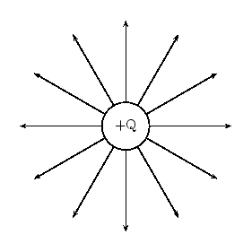

If there was a negative charge, the Electric Field lines would point inwards – towards the charge.

1. The more lines per unit area (or volume) indicate a stronger Electric Field. A stronger Electric Field is also indicated by longer Electric Field lines.
2. Both fields decrease in strength as 1/ r2 and are described by similar mathematical equations. The Gravitational Field is much weaker than the Electric Field. The Gravitational Field always provides an attractive force, where the Electric Field provides either an attractive or repulsive force depending on the signs of the charges involved.
3. The Electric Field.
4. The Electric Field due to each charge is calculated independently, and then they are vectorially added to find the total field at the point.

C**hapter Problems**

1. 900 N, repulsive
2. 1.3x10-1 N, attract
3. 7.7mC, positive
4. -8.0 x 10-8 C,

5.0 x 1011 electrons

1. 6.36 x 10-5 N, repulsive
2. 3.24 N, repulsive
3. 4.4 m
4. 12 m
5. 2.7 x 10-7 C, positive
6. -1.27 x 10-7 C, 7.95 x 1011 electrons
7. 2.0x10-3 N repulsive
8. kqeqe **/**Gmeme =4.2x1042
9. 1.25 x 103 N/C
10. 3.15 N
11. 1.3 x 103 N/C
12. 1.1 x 103 N/C toward the negative charge
13. 1.0 x 10-6 C
14. 4.8 x 103 N/C away from the positive charge
15. 2.3 x 10-6 C
16. FG = 1.29 x 10-34 N

FE  = 1.60 x 102 N; FE >> FG

1. FG = 3.21 x 10-48 N

FE  = 1.34 x 10-5 N; FE >> FG

1. 5.58 x 10-11 N/C
2. FG = 1.03 x 10-35 N

FE  = 1.28 x 101 N; FE >> FG

1. FG = 6.20 x 10-49 N

FE  = 2.58 x 10-6 N; FE >> FG

1. 1.58 N/C
2. 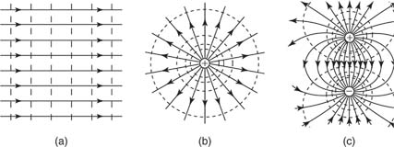
3. 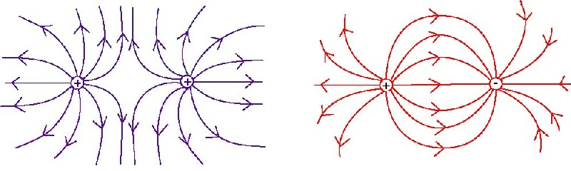
4. 

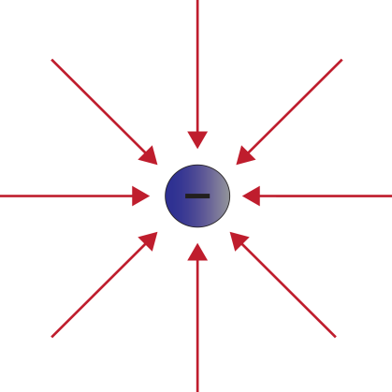

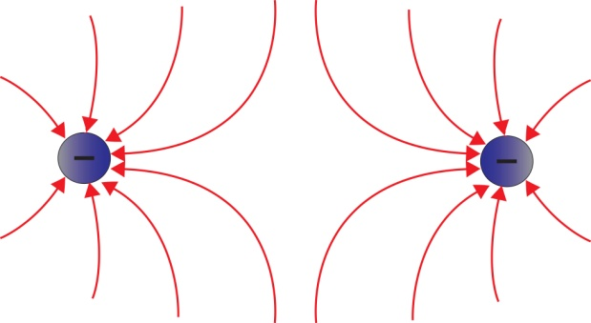

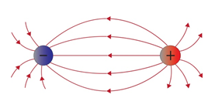



1. a. 2.6 x 103 N/C to the right

b. 7.9 x 102 N/C to the left

c. 1.8 x 103 N/C to the right

1. a. 1.7 x 104 N/C to the right

b. 9.7 x 103 N/C to the right

c. 2.3 x 102 N/C to the left

d. 2.7 x 104 N/C to the right

1. a. 8.1 x 103 N/C to the left

b. 7.0 x 102 N/C to the left

c. 8.8 x 103 N/C to the left

1. a. 1.2 x 104 N/C to the right

b. 5.5 x 103 N/C to the right

c. 4.6 x 102 N/C to the right

d. 1.8 x 104 N/C to the right

Free-Response

1. a. To the right  
   b. 1.5 x 105 N/C  
   c. To the right  
   d. 0.15 N  
   e. 60 m/s2
2. a. Down  
   b. 2.8 x 105 N/C  
   c.   
   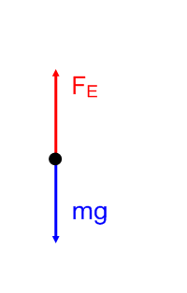  
     
   d. 1.25 x 10 -7 C; the sign should be negative
3. a. 1.8 x 104 N/C  
   b. 1.8 x 104 N/C  
   c.   
   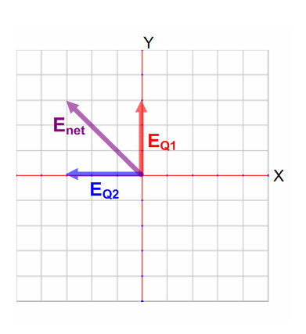  
   d. 2.5 x 104 N/C
4. a. To the left  
   b. 0.045 N  
   c.   
   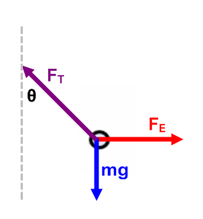  
   d. $θ$ = 24.7O  
   e. r = 0.25 m  
   f. i. 10.8 m/s2  
    ii.  
   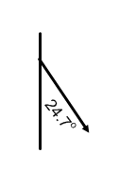
5. a.   
   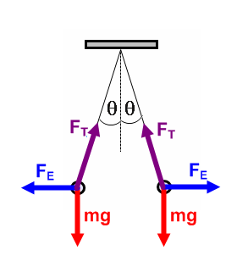  
   b. 1.52 m  
   c. 0.114 N  
   d. 5.4 x 10-4 C  
   e. 4.2 C