**PSI AP Physics I**

*Dynamics*

Multiple-Choice questions

1. After firing a cannon ball, the cannon moves in the opposite direction from the ball. This an example of:

A. Newton’s First Law

B. Newton’s Second Law

C. Newton’s Third Law

D. Newton’s Law of Gravitation

E. None of the above

1. In the absence of an external force, a moving object will

A. slow down and come to a stop

B. speed up

C. move with a constant speed in a straight line

D. turn to the right

E. turn to the left

1. A passenger who is standing and facing forward in a moving bus suddenly falls forward. This can be an indication of which of the following?

A. The bus speeds up.

B. The bus slows down.

C. The bus doesn’t change its speed.

D. The bus turns to the right.

E. The bus turns to the left.

1. A heavy box sits on a floor. The net force on the box can be represented as which of the following?

A. Non-zero vector pointing up

B. Non-zero vector pointing down

C. Non-zero vector pointing left

D. Non-zero vector pointing right

E. It is zero

1. A loaded truck collides with a car causing a large amount of damage to the car. Which of the following is true about the collision?

A. The force on the truck is greater than the force on the car.

B. The force on the car is greater than the force on the truck.

C. The force on the truck is the same in magnitude as the force on the car.

D. During the collision, the truck has a greater displacement than the car.

E. During the collision, the truck has a greater acceleration than the car.

1. The Earth pulls down on a railroad passenger car with an action force of 2x105 N. Which of the following is the reaction force?

A. The car pulls up on the Earth with 2x105 N

B. The car pushes down on the railroad tracks with 2x105 N

C. The railroad tracks push up on the car with 2x105 N

D. The buoyant force pushes up on the car with 2x105 N

E. The car pushes down on the Earth with 2x105 N

1. A railroad passenger car pushes down on the railroad tracks with a force of 2x105 N. Which of the following is the reaction force?

A. The car pulls up on the Earth with 2x105 N

B. The car pushes down on the railroad tracks with 2x105 N

C. The railroad tracks push up on the car with 2x105 N

D. The buoyant force pushes up on the car with 2x105 N

E. The car pushes down on the Earth with 2x105 N

**Multi-Correct:** Students will need to select all the correct answers to the question below in order to earn credit.

1. Which of the following is an inertial reference frame?

A. Amusement Park Carousel (merry-go-round)

B. Automobile traveling at a constant velocity

C. Automobile rounding a curve at a constant speed

D. International Space Station orbiting the earth and traveling at a constant speed

E. Spaceship traveling at a constant speed in a straight line

**Multi-Correct:** Students will need to select all the correct answers to the question below in order to earn credit.

1. Which of the following are true about the kinetic friction and the static friction forces?

A. Kinetic friction force is constant during an object’s motion

B. Static friction force does not change with an applied force

C. The coefficient of static friction is greater than the coefficient of kinetic friction

D. The coefficient of static friction is less than the coefficient of kinetic friction

E. Static friction force is in the direction of the net applied force

1. A box that weighs 25 N is pulled by an applied force of 10 N. The coefficient of static friction between the box and the surface is 0.5. The box will:

A. start moving and will continue to increase its velocity

B. start moving and maintain a constant velocity

C. start moving and continue to increase its acceleration

D. not move

E. start moving and then slow to a stop

1. A 25 N box is pulled across a frictionless surface by an applied force of 22 N. The coefficient of kinetic friction between the box and the surface is 0.3. Find the acceleration of the box. Use g = 10 m/s2.

A. 2.9 m/s2

B. 4.8 m/s2

C. 5.8 m/s2

D. 8.8 m/s2

E. 12 m/s2

1. An object is thrown straight up. How do we compare the net force on the object to its weight when it is at the highest point in the path?

A. It is greater than the weight

B. It is slightly less than the weight

C. It is zero

D. It is equal to the weight

E. It can’t be determined

1. An elevator car weighs 5500 N. If the car accelerates upwards at a rate of 4.0 m/s2, what is the tension in the support cable lifting the car? Use g = 10 m/s2.

A. 1600 N

B. 3300 N

C. 4400 N

D. 7700 N

E. 8700 N

*In the diagram below, a block of mass m slides down an inclined plane with a constant speed at an angle θ with respect to the horizontal. Use this diagram for questions 14 through 18.*

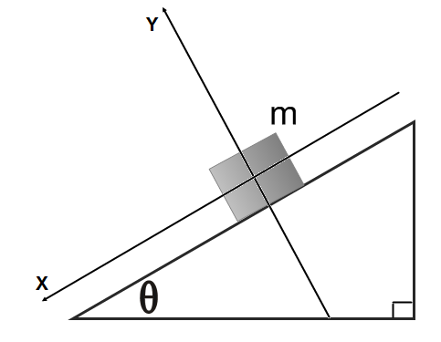

1. What is the x-component of the gravitational force?

A. mg cosθ

B. mg sinθ

C. mg tanθ

D. mg

E. zero

1. What is the y-component of the gravitational force?

A. mg cosθ

B. mg sinθ

C. mg tanθ

D. mg

E. zero

1. What is the normal force applied to the block?

A. mg cosθ

B. mg sinθ

C. mg tanθ

D. mg

E. zero

1. What is the kinetic friction force acting on the block?

A. µkmg cosθ

B. µkmg sinθ

C. µkmg tanθ

D. µkmg

E. zero

1. Which of the following is true about the coefficient of kinetic friction?

A. µk = cosθ

B. µk = sinθ

C. µk = tanθ

D. µk = mg

E. µk = 0

*In the diagram to the right, a block with a mass m = 5 kg slides down an inclined plane with an angle θ = 37°. The block maintains a constant acceleration a = 5.6 m/s2. (sin37° = 0.6, cos37° = 0.8). The coefficient of kinetic friction between the block and the inclined surface is 0.05. Use this diagram to answer questions 19 through 22.*

1. Which of the following diagrams best represents the gravitational force W, the frictional force f, and the normal force N that act on the block?

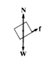

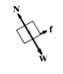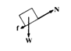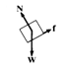

A. B. C. D. E.

1. What is the normal force on the block?

A. 50 N

B. 40 N

C. 30 N

D. 20 N

E. 10 N

1. What is the friction force between the block and the inclined plane?

A. 2 N

B. 5 N

C. 6 N

D. 30 N

E. 40 N

1. The coefficient of static friction between the block and the inclined plane is 0.4 and θ=250. The block is placed on the inclined plane. The block will:

A. not move

B. start moving down the incline and then stop before it reaches the bottom of the incline

C. start moving down the incline and continue to increase its velocity

D. start moving and increase its acceleration until it reaches the bottom of the incline

E. start moving and then its acceleration will decrease

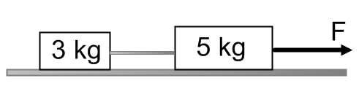

1. A system of two blocks is accelerated by an applied force of magnitude F on the frictionless horizontal surface. The tension in the string between the blocks is:

A. 3F

B. 5F

C. 3/8 F

D. 1/3 F

E. 1/5 F

1. A student pulls a wooden box along a rough horizontal floor at constant speed by means of a force *P* as shown to the right. Which of the following must be true?
2. P > f and N < W
3. P > f and N = W
4. P = f and N > W
5. P = f and N = W
6. P < f and N = W
7. As shown below, a boy pushes a sled of mass m across a rough horizontal surface by applying a force of magnitude F directed at an angle θ. The coefficient of kinetic friction between the sled and the surface is μk. The normal force on the sled is:

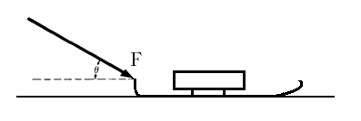A. mg

B. mg sinθ

C. mg cosθ

D. mg + F sinθ

E. mg – F sinθ

1. As shown below, a boy pushes a sled of mass m across a rough horizontal surface by applying a force of magnitude F directed at an angle θ. The coefficient of kinetic friction between the sled and the surface is μk. The friction force on the sled is:

A. μk (mg + Fsinθ)

B. μk (mg - Fsinθ)

C. μk (mg + Fcosθ)

D. μk (mg - Fcosθ)

E. μk mg

1. A block of mass m is pulled along a horizontal surface at constant speed v by a force Fapp , which acts at an angle of θ with the horizontal. The coefficient of kinetic friction between the block and the surface is μk.The normal force exerted on the block by the surface is:

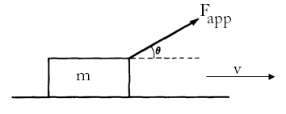A. mg ‑ Fapp cosθ

B. mg‑ Fapp sinθ

C. mg

D. mg + Fapp sinθ

E. mg + Fapp cosθ

1. A block of mass m is pulled along a horizontal surface at constant speed v by a force Fapp , which acts at an angle of θ with the horizontal. The coefficient of kinetic friction between the block and the surface is μk. The friction force on the block is:

A. μk (mg ‑ Fapp cosθ)

B. μk (mg‑ Fapp sinθ)

C. μk mg

D. μk (mg + Fapp sinθ)

E. μk (mg + Fapp cosθ)

1. An ideal spring obeys Hooke's law, F = ‑kx. A mass of 0.30 kg hung vertically from this spring stretches the spring 0.015 meter. The value of the spring constant is nearly:

A. 150 N/m

B. 200 N/m

C. 250 N/m

D. 300 N/m

E. 350 N/m

1. 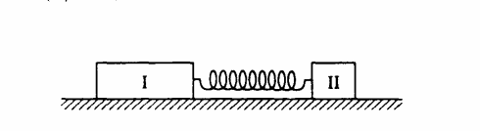Two blocks are attached by a compressed spring and are initially held at rest on a frictionless surface. The blocks are then released simultaneously. If block I has four times the mass of block II, which of the following quantities is the same for both blocks as the spring pushes the two blocks away from each other?  
   A. Speed

B. Velocity

C. Acceleration

D. Displacement

E. Force on each block

1. The two spheres have equal densities and are subject only to their mutual gravitational attraction. Which of the following quantities must have the same magnitude for both spheres?  
   A. Acceleration

B. Velocity

C. Kinetic Energy  
D. Displacement from the center of mass

E. Gravitational force

1. 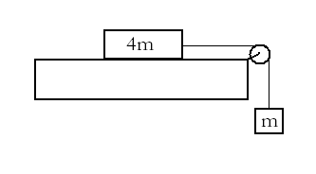A block of mass 4m can move without friction on a horizontal table. This block is attached to another block of mass m by a string that passes over a frictionless pulley. If the masses of the string and the pulley are negligible, what is the magnitude of the acceleration of the descending block?  
   A. g/5

B. g/4

C. g/3

D. 2g/3

E. g

**Multi-Correct:** Students will need to select all the correct answers to the question below in order to earn credit.

1. Three forces act on an object. Which of the following are true in order to keep the object in translational equilibrium?

A. The vector sum of the three forces must equal zero.

B. Two of the forces must be perpendicular.

C. The magnitudes of each of the three forces must be equal.

D. Each force has a magnitude of zero.

E. All three forces must be parallel.

1. 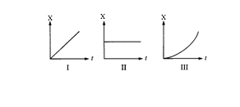Three objects can only move along a straight, level path. The graphs below show the position xof each of the objects plotted as a function of time t. The net force on the object is zero in which of the cases?

A. II only

B. III only

C. I and II only

D. I and III only

E. I, II and III

**Multi-Correct:** Students will need to select all the correct answers to the question below in order to earn credit.

1. A locomotive is pulling an empty freight car with a constant acceleration on a horizontal surface. The mass of the locomotive is five times the mass of the car. Which statement is true about the force applied by the car on the locomotive?
2. 5 times greater than the force of the locomotive on the car
3. 5 times less than the force of the locomotive on the car
4. Zero since they move with a constant acceleration
5. Equal to the force of the locomotive on the car
6. Opposite in direction to the force applied by the locomotive on the car
7. A block with initial velocity of 3 m/s slides 9 m across a rough horizontal surface before coming to rest. What is the coefficient of kinetic friction? Use g = 10 m/s2.

A. 0.10

B. 0.50

C. 0.30

D. 0.05

E. 0.01

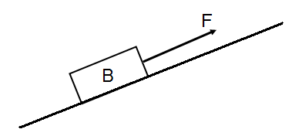

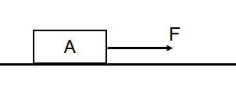

**Multi-Correct:** Students will need to select all the correct answers to the question below in order to earn credit.

1. A student performs an experiment on measuring friction forces in different trials. For trial A, she pulls a wooden block across a horizontal surface with a constant speed. For trial B, she inclines the same surface at angle θ with respect to the horizontal. Which of the following is true about the friction force between the block and the surface?
2. The friction force in trial B is greater.
3. The friction force in trial B is less.
4. The friction force is the same in both trials.
5. The friction force is independent of θ.

E. The friction force decreases with increasing angle.

1. A bus driver makes an emergency stop by slamming on the bus’s breaks. Later, he slams on the breaks again, but this time his speed is twice as much as the first time. How far will the bus skid compared to the first time?

A. The stopping distance stays the same.

B. The stopping distance is doubled.

C. The stopping distance is quadrupled.

D. The stopping distance is tripled.

E. The mass of the bus is required.

*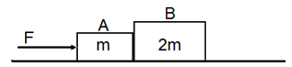In the diagram to the right, two blocks A and B with masses m and 2m are in contact on a horizontal frictionless surface. A force F is applied to block A. Use this diagram to answer questions 39 and 40.*

1. What is the acceleration of the system of two blocks?

A. F/m

B. F/2m

C. F/3m

D. F/4m

E. F/5m

1. What is the force exerted by block A on block B?

A. F/2

B. F/3

C. 3F/2

D. 2F/3

E. F/5

1. 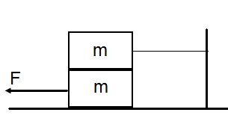A block with a mass m is placed on the top of an identical block m and the system of two blocks is at rest on a rough horizontal surface as shown below. The top block is tied to the wall. The coefficient of static friction between all surfaces is µs. What maximum value does force F reach before the lower block starts sliding to the left?

A. 3 µsmg

B. 2 µsmg

C. 4 µsmg

D. ½ µsmg

E. ¼ µsmg

1. 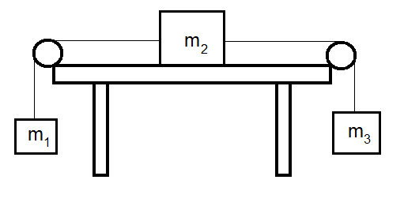Three blocks are connected with each other by two light strings. The blocks have different masses m2 > m3 >m1. The heaviest of the three blocks is placed on a frictionless table. The system of three blocks is released from rest. What is the acceleration of block m2?

A. (m2 - m3 - m1)g/(m1 + m2 + m3)

B. (m1 - m3 - m2)g/(m1 + m2 + m3)

C. (m3 - m1)g/(m1 + m2 + m3)

D. (m3 - m2- m1)g/(m1 + m2 + m3)

E. (m1 - m3)g/(m1 + m2 + m3)

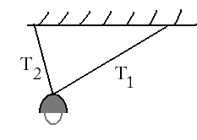

1. A lamp of mass m is suspended from two cables of unequal length as shown to the right. Which of the following is true about the tensions T1 and T2 in the cables?

A. Tl > T2

B. T1 = T2

C. T2 > T1

D. Tl - T2 = mg

E. Tl + T2 = mg

1. A ball of mass m is suspended from two massless strings of an equal length as shown below. The tension force in each string is:

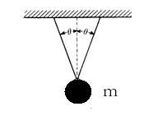  
A. ½ mgcosθ

B. 2mgcosθ

C . mgcosθ

D . mg/(cosθ)

E. mg/(2cosθ)

Multiple Choice

* 1. C
  2. C
  3. B
  4. E
  5. C
  6. A
  7. C
  8. B, E
  9. A, C
  10. D
  11. C
  12. D
  13. D
  14. B
  15. A
  16. A
  17. A
  18. C
  19. C
  20. B
  21. A
  22. C
  23. C
  24. A
  25. D
  26. A
  27. B
  28. B
  29. B
  30. E
  31. E
  32. A
  33. A, D
  34. C
  35. D, E
  36. D
  37. B, E
  38. C
  39. C
  40. D
  41. A
  42. C
  43. C
  44. E