***Waves Practice Problems***

*PSI AP Physics B* Name___________________________________

1. In a wave, the distance traveled by a wave during one period is called:
2. Amplitude (B) Frequency (C) Wavelength (D) Displacement



1. A stretched wire resonates in one loop. The midpoint of the wire oscillates with amplitude of A. What is the traveled distance of the midpoint in one period?
2. A (B) 2A (C) 3A (D) 4A
3. A distance between two consecutive crests is called the wave’s:
4. Period (B) Frequency (C) Amplitude (D) Wavelength
5. The frequency of a wave is doubled when the speed stays the same. Which of the following is true about the wavelength?
6. Doubles (B) Quadruples (C) Halved (D) Decreased to one-forth
7. A wave travels with a speed of v on a string of length L and mass M. The string is stretched to a tension force T. If the tension in the string is doubled, what is the new speed of the wave?
8. 2v (B)  v (C) v/2 (D )
9. A wave travels with a speed of v on a string of length L and mass M. The string is stretched to a tension force T. If the linear density is quadrupled, what is the new speed of the wave?

(A) 2v (B)  v (C) v/2 (D)

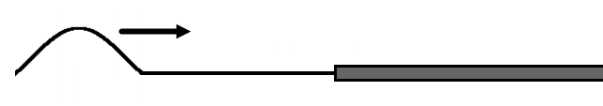

1. A wave pulse travels to the right along a thin string. The string is connected to a thick rope. Which of the following is true about the direction of the reflected and transmitted pulses?
2. They are both upright
3. They are both inverted
4. The reflected is upright and transmitted is inverted
5. The reflected is inverted and transmitted is upright

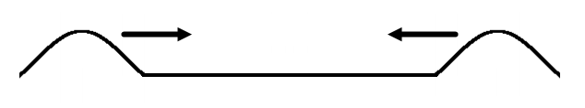

1. Two pulses of equal positive amplitude travel toward each other on a string. Which of the following is true about an oscillating point where the pulses pass through each other?
2. 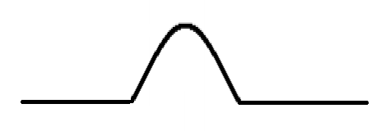

(B) 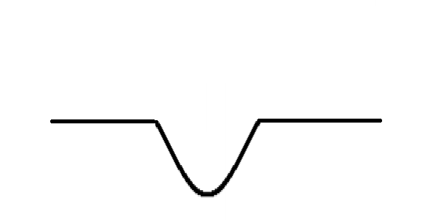

(C) 

(D) 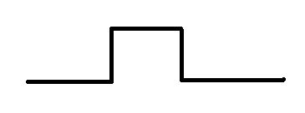

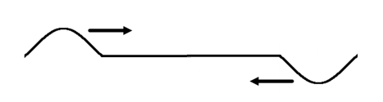

1. Two pulses of equal and opposite amplitude travel toward each other on a string. Which of the following is true about an oscillating point where the pulses pass through each other?

(A)

(B) 

(C) 

(D) 

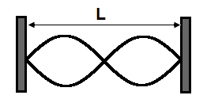

1. A string of length L oscillates at a frequency at which a standing wave is produced. What is the wavelength of the wave in the string?
2. L (B) L/2 (C) L/3 (D) 2L/3

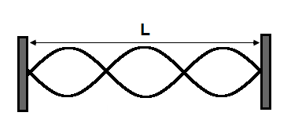

1. A string of length L oscillates at a frequency at which a standing wave is produced. What is the wavelength of the wave in the string?
2. L (B) L/2 (C) L/3 (D) 2L/3

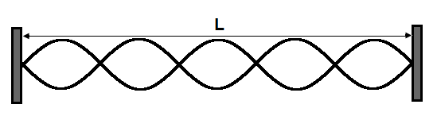

1. A string of length L oscillates at a frequency at which a standing wave is produced. What is the wavelength of the wave in the string?
2. L (B) L/5 (C) 2L/3 (D) 2L/5

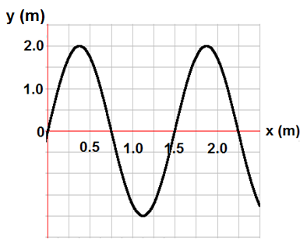

1. A “snapshot” of a wave is given on the graph. What is the amplitude of oscillations?
2. 0.5 m (B) 1 m (C) 1.5 m (D) 2 m



1. A “snapshot” of a wave is given on the graph. What is the wavelength?
2. 1 m (B) 1.5 m (C) 2 m (D) 2.5 m



1. A “snapshot” of a wave is given on the graph. What is the speed of the wave if the frequency of oscillation is 16 Hz?

(A) 8 m/s (B) 16 m/s (C) 24 m/s (D) 36 m/s

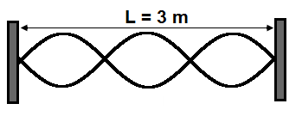

1. A string with a length of 3 m oscillates at a frequency 6 Hz. What is the speed of the wave in the string?
2. 9 m/s (B) 12 m/s (C) 15 m/s (D) 18 m/s



1. A string with a length of 3 m oscillates at a frequency 6 Hz. What is the fundamental frequency?
2. 2 Hz (B) 3 Hz (C) 4 Hz (D) 6 Hz

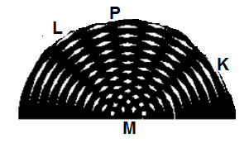

1. The wave interference on a surface of water is presented by the diagram. Which of the following would represent the regions of maximum amplitude of the resultant oscillations?

I from M to L II from M to P III from M to K

(A) only I

(B) only II

(C) only III

(D) only I and III

1. A wave with a wavelength of 50 cm is traveling on a string. The graph below shows the position as a function of time for a point on the string. If the frequency of the wave is cut to half what is the average speed of the point?
2. 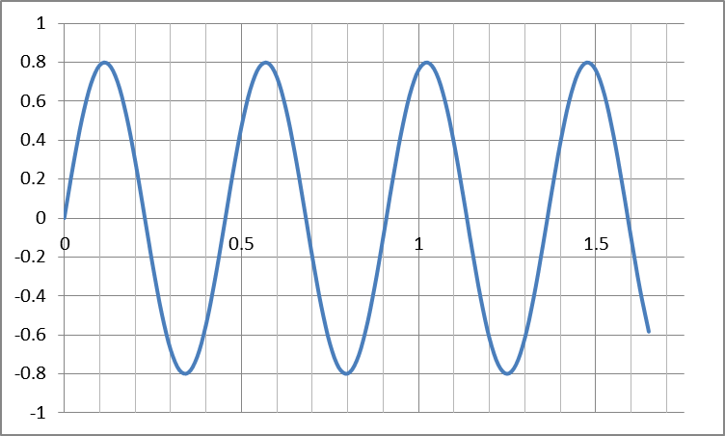3.2 m/s
3. 0.8 m/s
4. 1.1 m/s
5. 2.2 m/s
6. A wave is originating from a source below. At point A the intensity is I0. What is the intensity at point B?



1. 2I0
2. I0
3. I0/2
4. I0/4

Multi Correct Questions

Directions: For each of the following, two of the suggested answers will be correct. Select the best two choices to earn credit. No partial credit will be earned if only one correct choice is selected.

1. The figure below represents a snapshot of a wave traveling though some unknown medium. Which two choices are correct regarding this wave?

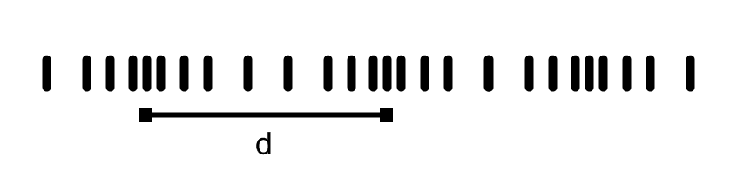

1. The distance between any two adjacent lines is the amplitude.
2. The wavelength is represented by d.
3. The wave is a longitudinal wave.
4. The frequency is the number of lines in the distance d.
5. Two waves travel on two different strings made of the same material and under the same tension force as shown below. What can be concluded about the waves? Select two answers.

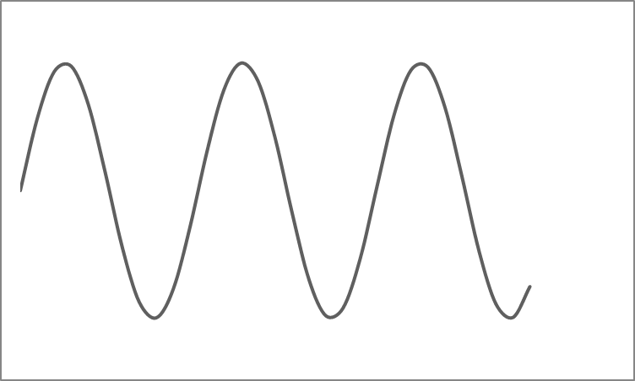

1. The waves have the same wavelength.
2. The waves have the same frequency.
3. The waves have the same speed.
4. The waves have the same amplitude.

**Free Response**

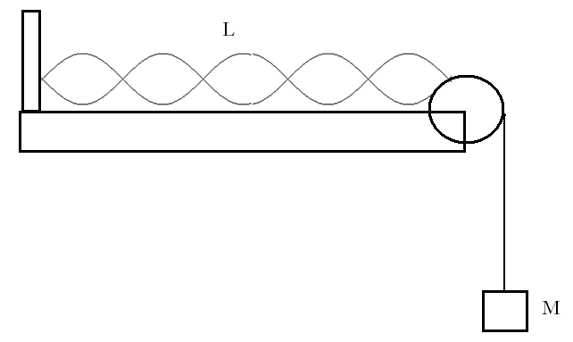

1. A string that is a length of 2.5 m resonates in five loops as shown above. The string linear density is 0.05 kg/m and the suspended mass is 0.5 kg.
2. What is the wavelength?
3. What is the wave speed?
4. What is the frequency of oscillations?
5. What will happen to the number of loops if the suspended mass is increased?

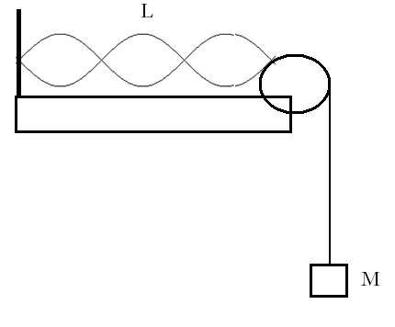

1. A string with a length of 1.5 m resonates in three loops as shown above. The string linear density is 0.03 kg/m and the suspended mass is 1.2 kg.
2. What is the wavelength?
3. What is the wave speed?
4. What is the frequency of oscillations?
5. What will happen to the number of loops if the suspended mass is increased?

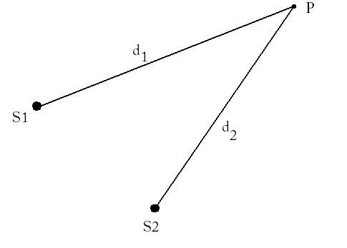

1. Two waves on the surface of water are generated by two independent sources vibrating at the same frequency 1 Hz. The waves travel at a speed of 2.4 m/s. A point P is located 3.8 m from source 1 and 5.0 m from source 2.
2. What is the wavelength of the waves?
3. What is the extra distance traveled by the second wave before it reaches point P?
4. What is the result of the interference at the point P?
5. What will be the result of interference at the point P if source 2 is moved 3.6 m further back?
6. What will be the result of interference at the point P if source 2 is moved 4.2 m further back?



1. Two waves on the surface of water are generated by two independent sources vibrating at the same frequency 4.0 Hz. The waves travel at a speed of 3.2 m/s. A point P is located 4.2 m from source 1 and 4.6 m from source 2.
2. What is the wavelength of the waves?
3. What is the extra distance traveled by the second wave before it reaches point P?
4. What is the result of the interference at the point P?
5. What will be the result of interference at the point P if source 2 is moved 1.2 m further back?
6. What will be the result of interference at the point P if source 2 is moved 1.6 m further back?

**Qualitative/ Quantitative Questions**

1. Two wave pulses approach each other on the same string and the waves have the same wavelength and amplitude. The waves are the same distance from point A.

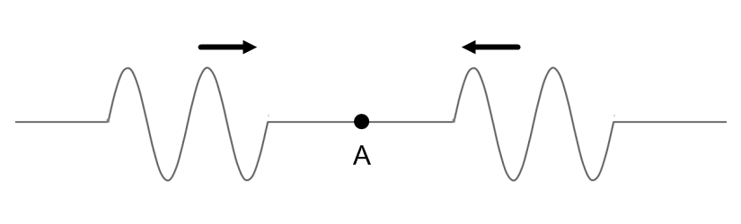

* 1. On the figure below, draw the shape of the string as the pulses overlap ½ of the wave through both of them.



* 1. On the figure below draw the displacement as a function of time for the point A from the moment the pulses meet until they have passed each other.



* 1. If instead of wave pulses, the sources of the waves were set to oscillate continuously, describe what would happen and how you would calculate the speed of the wave on the string.

1. Two strings of the same material are connected to the same oscillator, pulled tightly over two light, frictionless pulleys and then connected to two 5 kg hanging masses as shown in the diagram. The oscillator can be set anywhere from 1 to 500 Hz. The linear density of the strings is 5.317x10-3 kg/m. The only difference between the two strings is the length. The top string is 2 m long and the bottom string is 1.6 m long (both are measured from the oscillator to the pulley). Two students make predictions about when a frequency will be reached that will produce standing waves on both strings at the same time.

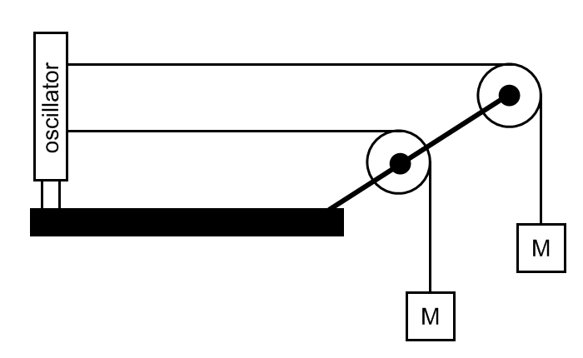

Student 1 predicts that the top string will have more loops than the bottom string because the speed of the wave on the top string is greater than the speed of the wave on the bottom string since the top string is longer.

Student 2 predicts that both strings will have the same number of loops because the speed of the waves on both strings is the same since they both have the same mass attached to them.

* 1. Which student (if any) made a correct prediction? (Ignore their reasoning for the moment.)
  2. Which student or students have correcting reasoning? Explain your answer.
  3. How many loops will be on each string the first time a stand wave is produced on both strings at the same time?
  4. Calculate the frequency or frequencies that can be set so that the oscillator will produce a standing wave for both strings at the same time.

**Answers**

**Multiple Choice**

1. C
2. D
3. D
4. C
5. B
6. C
7. D
8. A
9. C
10. A
11. D
12. D
13. D
14. B
15. C
16. B
17. A
18. D
19. A
20. D
21. B, C
22. C, D

**Free Response**

1. a. 1 m  
   b. 9.89 m/s  
   c. 9.89 Hz  
   d. The number of loops would decrease
2. a. 1 m  
   b. 19.79 m/s  
   c. 19.79 Hz  
   d. The number of loops would decrease
3. a. 2.4 m  
   b. 1.2m  
   c. Destructive  
   d. Constructive  
   e. Partially Destructive
4. a. 0.8 m  
   b. 0.4 m  
   c. Destruction  
   d. Construction  
   e. Partially Destructive
5. a.

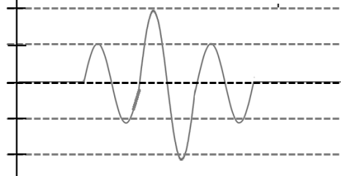

b. 

1. The oscillations would result in a standing wave. In order to calculate the speed of the wave you would need the frequency set by the sources and the wavelength. You can calculate the wavelength using $λ=\frac{2L}{n}$ where L is the length of the string and n is the number of loops in the standing wave. Then you can calculate the speed using $v=λf$.
2. The first student has the correct prediction.
3. The second student was correct in saying that both strings would have the same wave speed because they both have the same mass attached. The speed of a wave on a string is determined by $v=\sqrt{\frac{F_{T}}{μ}}$ where FT is the force of tension (which is equal to Mg) and μ is the linear density of the string.
4. The top string will have 5 loops and the bottom string will have 4 loops.
5. The speed of the wave is 96 m/s.

The frequencies that will result in a standing wave on both strings at the same time are 120, 240, 360, and 480 Hz.