***Simple Harmonic Motion***

***Practice Problems***

*PSI AP Physics 1* Name___________________________________

Multiple Choice Questions

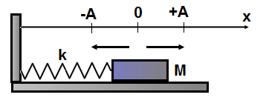

1. A block with a mass M is attached to a spring with a spring constant k. The block undergoes SHM. Where is the block located when its velocity is a maximum in magnitude?
2. x = 0 B) x = ±A C) x = +A/2 D) x = -A/2
3. A block with a mass M is attached to a spring with a spring constant k. The block undergoes SHM. Where is the block located when its potential energy is a maximum?
4. x = 0 B) x = ±A C) x = +A/2 D) x = -A/2



1. A block with a mass M is attached to a spring with a spring constant k. The block undergoes SHM. Where is the block located when its acceleration is a minimum in magnitude?
2. x = 0 B) x = ±A C) x = +A/2 D) x = -A/2
3. A mass-spring oscillating system undergoes SHM with a period T. What is the period of the system if the amplitude is doubled?
4. 2T B) 4T C) T D) T/2
5. A mass-spring oscillating system undergoes SHM with a period T when it is located on Earth. What is the period of the system when it is located on Moon?
6. 6T B) T/6 C) T D)  T
7. A block with a mass M is attached to a vertical spring with a spring constant k. When the block is displaced from equilibrium and released its period is T. A second identical spring k is added to the first spring in parallel. What is the period of oscillations when the block is suspended from two springs?
8. 2T B)  T C) T D) 

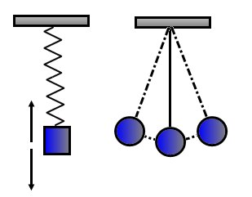

1. Two oscillating systems: spring-mass and simple pendulum undergo SHM with an identical period T. If the mass in each system is doubled which of the following is true about the new period?

Mass-spring Simple pendulum

1.  
2.  
3.  
4.  
5. An object undergoes SHM and position as a function of time is presented by the following formula: x= (0.1 m) Sin (4πt). What is the period of oscillations?
6. 2 s B) 0.1 s C) 0.5 s D) 4 s

1. An object undergoes SHM and position as a function of time is presented by the following formula: x= (0.5 m) Cos (πt). What is the amplitude of oscillations?
2. 2 m B) 1 m C) 0.5 m D) 0.1 m

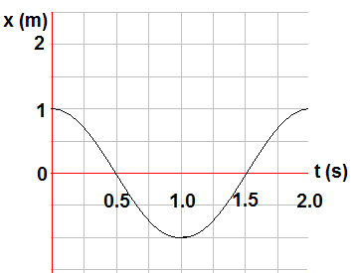

1. The position as a function of time of a mass-spring oscillating system is presented by the graph. Which of the following is true about velocity and acceleration at the time 1.5 s?

Velocity Acceleration

A) v >0 a < 0

B) v =0 a > 0

C) v < 0 a = 0

D) v >0 a = 0

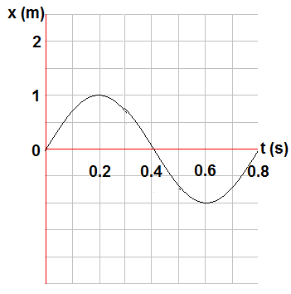

1. A particle undergoes SHM represented by the graph. Which of the following is true about the amplitude and period of oscillations?

Amplitude Period

1. 1 m 0.8 s
2. 1 m 0.1 s
3. 1 m 0.4 s
4. 2 m 0.4 s

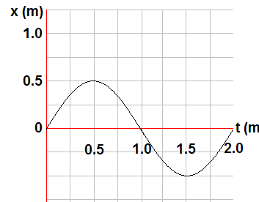

1. An object oscillates at the end of a spring. The position as a function of time is presented by the graph. Which of the following formulas represent the position and velocity of the object?

Position Velocity

1. x = (0.5) Sin(πt) v = (0.5π) Sin(πt)
2. x = (0.5) Sin(πt) v = (0.5π) Cos(πt)
3. x = (0.5) Cos(πt) v = (0.5π) Sin(πt)
4. x = (0.5π) Sin(πt) v = (0.5) Sin(πt)
5. A simple pendulum oscillates with a period T. If the mass of the pendulum is doubled what is the new period of the pendulum?
6. T/2 B) 2T C) T D)  T
7. A simple pendulum oscillates with a period T. If the length of the pendulum is doubled what is the new period of the pendulum?
8. 2T B) T C)  T D) 
9. What is the length of a simple pendulum if it oscillates with a period of 2 s?
10. 2.0 m B) 1.0 m C) 0.5 m D) 0.4 m

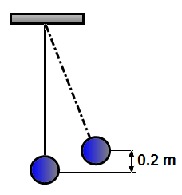

1. A simple pendulum consists of a mass M attached to a vertical string L. When the string is displaced to the right the ball moves up by a distance 0.2 m. When the ball is released from rest what is the maximum speed?
2. 1 m/s B) 2 m/s C) 3 m/s D) 4 m/s

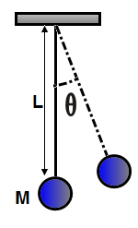

1. A simple pendulum consists of a mass M attached to a vertical string L. The string is displaced to the right by an angle ϴ. When the pendulum is released from rest what is the speed of the ball at the lowest point?
2. 2 gL B)  C) $\sqrt{2gL \cos{θ}}$ D) 



1. A block of mass M is attached to a horizontal spring k. The block undergoes SHM with amplitude of A. Which of the following graphs represents the elastic potential energy as a function of position x?

A)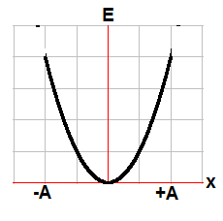B)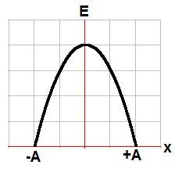

C)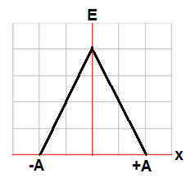D)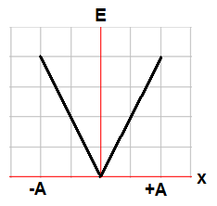



1. A block of mass M is attached to a horizontal spring k. The block undergoes SHM with amplitude of A. Which of the following graphs represents the kinetic energy as a function of position x?

A)B)

C)D) 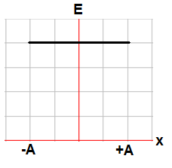

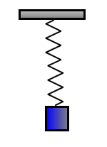

1. A 0.9 kg block is attached to an unstretched spring with a spring constant of 10 N/m. The block is released from rest. How long does it take for the block to return to its initial position?
2. 0.3π s B) 0.5π s C) 0.6π s D) 0.9π s

Multi Correct Questions

Directions: For each of the following, two of the suggested answers will be correct. Select the best two choices to earn credit. No partial credit will be earned if only one correct choice is selected.

1. A student wishes to determine the spring constant of a spring in a mass-spring oscillating system. Which of the following pieces of equipment will provide the measured quantities needed for this calculation?
2. Meterstick
3. Balance
4. Stopwatch
5. Accelerometer
6. When an object in simple harmonic motion reaches its maximum displacement, which of the following statements are true?
7. The acceleration of the object is zero.
8. The kinetic energy is at a maximum.
9. The velocity of the object is zero.
10. The potential energy is at a maximum.

Free Response Problems

1. A 0.4 kg object is attached to a horizontal spring undergoes SHM with the total energy of 0.2 J. The potential energy as a function of position presented by the graph below:

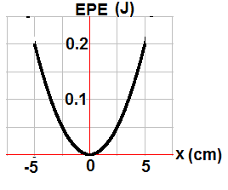

1. What is the amplitude of oscillations?
2. What is the spring constant?
3. What is the kinetic energy of the system at point x = 2.5 cm?
4. Indicate point or points where the kinetic energy equals the potential energy of the system.
5. What is the maximum speed of the object?
6. A 0.2 kg object is attached to a horizontal spring undergoes SHM with the total energy of 0.4 J. The kinetic energy as a function of position presented by the graph below:

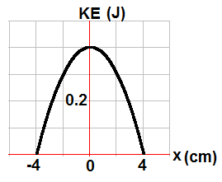

1. What is the maximum displacement from equilibrium?
2. What is the maximum speed of the object?
3. What is the spring constant?
4. Indicate point or points where the kinetic energy equals the potential energy of the system.
5. What is the potential energy of the system at point x = 2 cm?

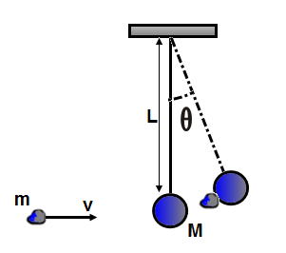

1. A 20 g piece of clay moving at a speed of 50 m/s strikes a 500 g pendulum bob at rest. The length of a string is 0.8 m. After the collision the clay-bob system starts to oscillate as a simple pendulum.
2. What is the speed of the clay-bob system after the collision?
3. What is the maximum angular displacement of the pendulum?
4. What is the period of the clay-bob oscillating system?
5. What is the total energy of the oscillating system?

The pendulum bob makes one complete oscillation and the string breaks at the lowest point.

1. What is the maximum horizontal distance of the bob when it strikes the floor 0.7 m below?

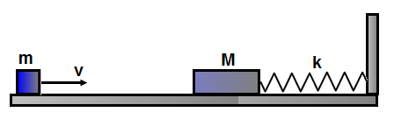

1. A small block moving with a constant speed v collides inelastically with a block M attached to one end of a spring k. The other end of the spring is connected to a stationary wall. Ignore friction between the blocks and the surface.
2. What is the speed of the system of two blocks after the collision?
3. What is amplitude of oscillations of the system of two blocks?
4. What is the period of oscillations?
5. What is the total energy of the oscillating system?

Qualitative/Quantitative Questions

1. A student sets a 0.25 kg object into simple harmonic motion on a horizontal frictionless surface. The graphs for position and velocity as functions of time are shown below.

On the axes below, sketch a) the kinetic energy of the object, b) the potential energy, and c) the acceleration as functions of time. Make sure to label any intercepts, asymptotes, maxima or minima.

1. 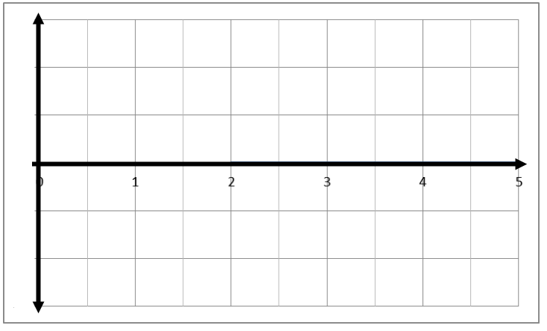
2. 
3. 
4. A student needs to determine whether the relationship between the restoring force and the amount stretched of a rubber band is the same as an ideal spring.
5. Describe a procedure that the student could use to collect the necessary data. Make sure to include all equipment needed and values to be measured as well as how the student would analyze that data.

Assume that the student has determined that the rubber band does indeed act like an ideal spring and has calculated its spring constant.

1. The student is now given an object with an unknown mass and is asked to use the rubber band to find the mass of the object. Describe a procedure using the ideas you learned in the SHM chapter as well as the object, rubber band, and any other equipment that the student could use to determine the mass of the object.

Answer Key

Multiple Choice

1. A
2. B
3. A
4. C
5. C
6. D
7. C
8. C
9. C
10. D
11. A
12. B
13. C
14. C
15. B
16. B
17. D
18. A
19. B
20. C
21. B & C
22. C & D

Free Response

1. a. 5 cm  
   b. 160 N/m  
   c. 0.15 J  
   d. Any point on the curve where the y-axis equals 0.1 J  
   e. 1 m/s
2. a. 4 cm  
   b. 2 m/s  
   c. 500 N/m  
   d. Any point on the curve where the y-axis equals 0.2 J  
   e. 0.1 J
3. a. 1.92 m/s  
   b. 40O  
   c. 1.8 s  
   d. 0.96 J  
   e. 0.73 m
4. a. $v^{'}= \frac{mv}{M+m}$  
   b. $x= \frac{mv}{\sqrt{k(M+m)}}$  
   c. $T=2π\sqrt{\frac{M+m}{k}}$  
   d. $E_{T}= \frac{1}{2}\frac{{(mv)}^{2}}{M+m}$
5. a.

b.

c.

1. a. The student could use some known masses, a ruler, and a stand. Hang the rubber band on the stand and measure its length. Then hang the various masses and measure the amounts they stretch the rubber band (which is the displacement from equilibrium). Since $F=kx$ and $k=\frac{F}{x}$, the student can graph the force (which is the weight of the mass) vs. the displacement from equilibrium. If it is a linear relationship, then the rubber band behaves like and ideal spring.

b. The student would need the unknown mass, the rubber band, a stand, and a timer. The student should attach the rubber band to the stand and the mass to the rubber band. Then pull the mass down to set it into SHM and time 10 cycles. Divide that time by 10 to calculate the period. Now the student can use the equation $T=2π\sqrt{\frac{m}{k}}$ to find the unknown mass.