**PSI AP Physics 1**

*Circular Motion*

Multiple Choice

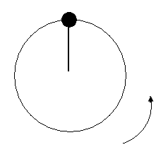

1. A ball is fastened to a string and is swung in a vertical circle. When the ball is at the highest point of the circle its velocity and acceleration directions are:
2. 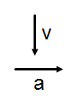 (B) 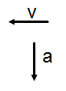 (C) 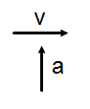 (D) 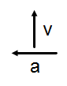

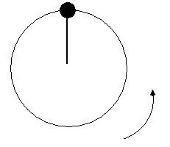

1. A ball with a mass m is fastened to a string and is swung in a vertical circle. When the ball is at the highest point of the circle the tension in the string is:
2. mg (B) mg + ma (C) ma -mg (D) mg/ma
3. 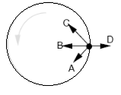An object, shown in the accompanying figure, moves in uniform circular motion. Which arrow best depicts the net force acting on the object at the instant shown?
4. A (B) B (C) C (D) D

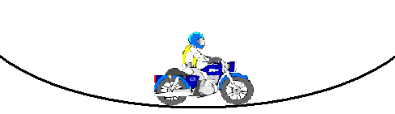

1. A motorcyclist moves at a constant speed down one hill and up another hill along the smooth curved surface. When the motorcyclist reaches the lowest point of the curve its velocity and acceleration directions are:
2. 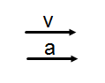 (B)  (C) 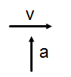 (D) 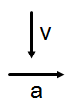
3. 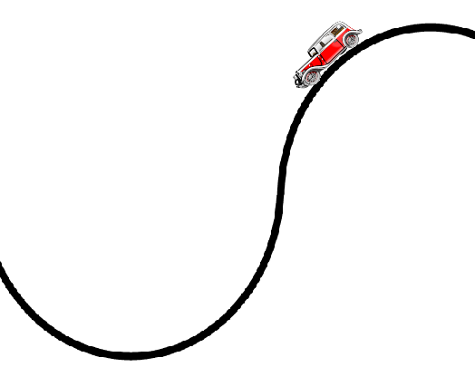Acar moves along the curved track. What is the apparent weight of the driver when the car reaches the lowest point of the curve?
4. mg (B) mg + ma (C) ma –mg

(D) mg/ma

1. Acar moves along the curved track. What is the direction of FN of the driver when the car reaches the lowest point of the curve?
2. 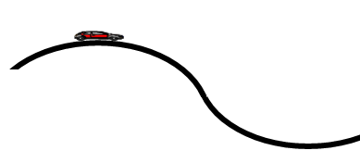Upward (B) Downward (C) Forward (D) Backward
3. A car is traveling on a road in hilly terrain, see figure above. Assume the car has speed *v* and the tops and bottoms of the hills have radius of curvature *R*. The driver of the car is most likely to feel weightless:
4. at the top of a hill when *v*  
5. at the bottom of a hill when *v*  
6. going down a hill when *v*  
7. at the top of a hill when *v*  

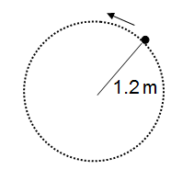Questions 8-9

A 0.2 kg ball rotates at a constant speed of 3 m/s on the end of 1.2 m long string. The string describes a horizontal circle.

1. 8. What is the centripetal acceleration of the object?

1. 1.2 m/s2 (B) 3.0 m/s2 (C) 7.5 m/s2 (D) 3.2 m/s2
2. What is the centripetal force exerted on the object?
4. (A) 1.0 N (B) 1.2 N (C) 0.2 N (D) 1.5 N
5. When a student stands on a rotating table, the frictional force exerted on the student by the table is
6. (A) greater in magnitude than the frictional force exerted on the table by the student
7. (B) less in magnitude than the frictional force exerted on the table by the student
8. (C) equal in magnitude than the frictional force exerted on the table by the student

(D) directed away from the center of the table

1. A child whirls a ball at the end of a rope, in a uniform circular motion. Which of the following statements is **NOT** true?
2. The speed of the ball is constant.
3. The velocity of the ball is constant.
4. The radius is constant
5. The magnitude of the ball’s acceleration is constant.

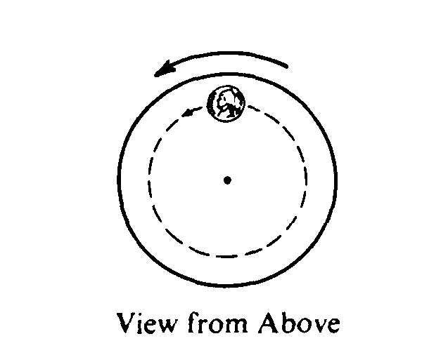12. The horizontal table rotates at a constant speed. As viewed from above, a coin on the table moves counterclockwise in a circle. Which of the following vectors best represents the direction of the frictional force exerted on the coin by the table when the coin is in the position shown?  
(A)  (B)  (C)  (D) 

1. A centripetal force F is applied to an eraser moving at a constant speed v in a horizontal circle of radius r. If the same force is applied, but the radius is halved, what happens to the speed of the eraser?
2. Increased by a factor of 2
3. decreased by a factor of 2
4. increased by a factor of √2
5. decreased by a factor of √2
6. A centripetal force F is applied to an object moving at a constant speed v in a horizontal circle of radius r. If the radius is quadrupled and the speed is doubled, what happens to the centripetal force?
7. Increased by a factor of 2
8. decreased by a factor of 2
9. doesn’t change
10. increased by a factor of √2

Questions 15-17

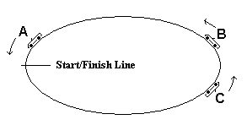The diagram below is a snapshot of three cars all moving counterclockwise during a one lap race on an elliptical track.

15. Which car, at the moment of the snapshot, has the smallest displacement?

(A) car A (B) car B (C) car C (D) all three cars have the same displacement

16. Which car at the moment of the snapshot must have non-zero acceleration?

(A) car A (B) car B (C) car C (D) all three cars have non-zero acceleration

17. Which car can at the moment of the snapshot must have a centripetal force directed to the center of the center of the curvature?

(A) car A (B) car B (C) car C

D) all three cars must have the centripetal force directed to the center of the curvature

18. A roller coaster car is on a track that forms a circular loop of radius R in the vertical plane. If the car is to just maintain contact with track at the top of the loop, what is the minimum value for its velocity at this point?

(A) gR (B) 0.5gR (C) 2gR (D) (gR)1/2

19. A coin rests on a turntable a distance r from the axis of rotation. The turntable rotates with a constant speed of v. What is the minimum coefficient of static friction between the turntable and the coin?

(A) v2rg (B) v2/rg (C) rg/v2 (D) v2/r

20. A car goes around a curve of radius r at a constant speed v. The coefficient of static friction between the tires and the surface is µ. What is the maximum value of the car’s velocity in order to prevent car from skidding of the road?

(A) µ rg (B) µ r/g (C) (µrg)1/2 (D) g/µr

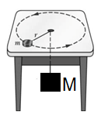

1. 21. An object m is tied to one end of a string, moves in a circle with a constant speed v on a horizontal frictionless table. The second end of the string is connected to a big mass M and goes through a small hole in the table. What is the value of M if it stays in equilibrium?
2. (A) mv2/rg (B) v2/rmg (C) rg/mv2 (D) mv2r/g
3. A heavy (2.0 kg) point-like object rests 2.0m from the center of a rough turntable as the turntable rotates. The period of the turntable's rotation is 5.0 seconds. The coefficient of kinetic friction between the object and turntable is 0.50, while the coefficient of static friction is 0.80. What is the magnitude of the force of friction acting on the object?
4. 19.6N (B) 16.0N (C) 9.8N (D)6.3N
5. Two identical cars, one on the moon and one on Earth, are rounding banked curves at the same speed with the same radius and different angles. The acceleration due to gravity on the moon is 1/6 that of Earth. How do the centripetal accelerations of each car compare?
6. The centripetal acceleration of the car on Earth is less than that on the moon.
7. The centripetal acceleration of the car on Earth is greater than that on the moon.
8. The centripetal accelerations are the same for both cars.
9. This cannot be determined without knowing the radius and the angle.

Multi-Correct Questions

Directions: For each of the following, two of the suggested answers will be correct. Select the best two choices to earn credit. No partial credit will be earned if only one correct choice is selected.

1. Four particles have the following masses (in terms of m), speeds (in terms of v), and radii (in terms of r). Which two particles have the same centripetal force?

|  |  |  |  |
| --- | --- | --- | --- |
| **Particle** | **Mass** | **Speed** | **Radius** |
| 1 | m | v | r |
| 2 | m/2 | 2v | 2r |
| 3 | 2m | v/2 | r |
| 4 | m | 2v | 3r |

1. Particle 1
2. Particle 2
3. Particle 3
4. Particle 4
5. A stone is tied to a string and whirled in a vertical circle at a radius. Which of the following cannot be true?
6. The string is most likely to break at the bottom of the circle.
7. The tension force is the same everywhere in the circle.
8. The tension force and the weight of the stone always affect the centripetal force.
9. The tension is the least when the stone is at the top of the circle.

Free Response

1. Determine the minimum angle at which a frictionless road should be banked so that a car traveling at 20.0 m/s can safely negotiate the curve if the radius of the curve is 200.0 m.
2. Determine the velocity that a car should have while traveling around a frictionless curve of radius 100m and that is banked 20 degrees.
3. If the road in number 2 was not frictionless, which way would the frictional force point if the car exceeded this velocity? Which way would it point if the car went slower than this velocity?
4. 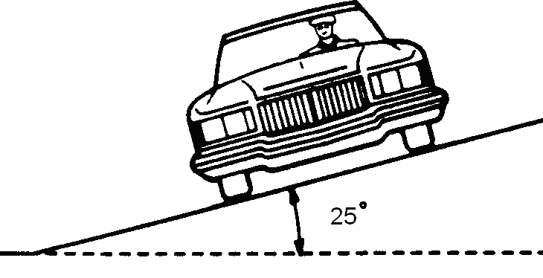A curve with a radius of 50 m is banked at an angle of 25˚. The coefficient of static friction between the tires and the roadway is 0.3.
5. Find the correct speed of an automobile that does not require any friction force to prevent skidding.
6. What is the maximum speed the automobile can have before sliding up the banking?
7. What is the minimum speed the automobile can have before sliding down the banking?

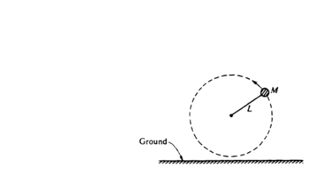

1. A ball of mass M attached to a string of length L moves in a circle in a vertical plane as shown above. At the top of the circular path, the tension in the string is twice the weight of the ball. At the bottom, the ball just clears the ground. Air resistance is negligible. Express all answers in terms of M, L, and g.
2. Determine the magnitude and direction of the net force on the ball when it is at the top.
3. Determine the speed vo of the ball at the top.

After a few circles, the string breaks when the ball is at the highest point.

1. Determine the time it takes the ball to reach the ground.
2. Determine the horizontal distance the ball travels before hitting the ground.

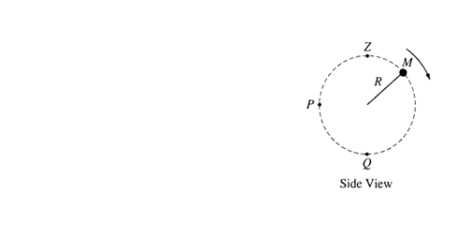

1. A ball of mass M is attached to a string of length R and negligible mass. The ball moves clockwise in a vertical circle, as shown above. When the ball is at point P, the string is horizontal. Point Q is at the bottom of the circle and point Z is at the top of the circle. Air resistance is negligible. Express all algebraic answers in terms of the given quantities and fundamental constants.
2. On the figures below, draw and label all the forces exerted on the ball when it is at points P and Q, respectively.

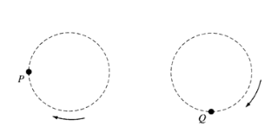

1. Derive an expression for vmin the minimum speed the ball can have at point Z without leaving the circular path.
2. The maximum tension the string can have without breaking is Tmax Derive an expression for vmax, the maximum speed the ball can have at point Q without breaking the string.
3. Suppose that the string breaks at the instant the ball is at point P. Describe the motion of the ball immediately after the string breaks.

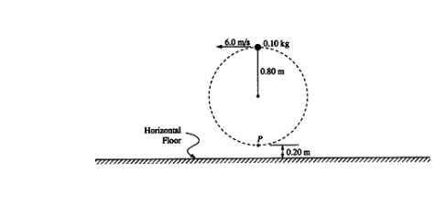

1. A 0.10-kilogram solid rubber ball is attached to the end of an 0.80-meter length of light thread. The ball is swung in a vertical circle, as shown in the diagram above. Point P, the lowest point of the circle, is 0.20 meter above the floor. The speed of the ball at the top of the circle is 6.0 meters per second, and the total energy of the ball is kept constant.
2. Determine the total energy of the ball, using the floor as the zero point for gravitational potential energy.
3. Determine the speed of the ball at point P, the lowest point of the circle.
4. Determine the tension in the thread at
5. the top of the circle;
6. the bottom of the circle.

The ball only reaches the top of the circle once before the thread breaks when the ball is at the lowest point of the circle.

1. Determine the horizontal distance that the ball travels before hitting the floor.

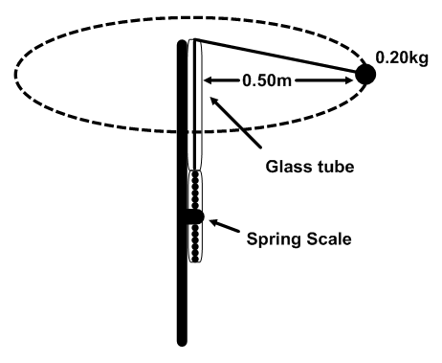

1. To study circular motion, two students use the hand-held device shown above; this consists of a rod on which a spring scale is attached. A polished glass tube attached at the top serves as a guide for a light cord attached the spring scale. A ball of mass 0.200 kg is attached to the other end of the cord. One student swings the teal around at constant speed in a horizontal circle with a radius of 0.500 m. Assume friction and air resistance are negligible.
2. Explain how the students, by using a timer and the information given above, can determine the speed of the ball as it is revolving.
3. How much work is done by the cord in one revolution? Explain how you arrived at your answer.
4. The speed of the ball is determined to be 3.7 m/s. Assuming that the cord is horizontal as it swings, calculate the expected tension in the cord.
5. The actual tension in the cord as measured by the spring scale is 5.8 N. What is the percent difference between this measured value of the tension and the value calculated in part c.?
6. The students find that, despite their best efforts, they cannot swing the ball so that the cord remains exactly horizontal.
7. On the picture of the ball, draw vectors to represent the forces acting on the ball and identify the force that each vector represents.
8. Explain why it is not possible for the ball to swing so that the cord remains exactly horizontal.
9. Calculate the angle that the cord makes with the horizontal.

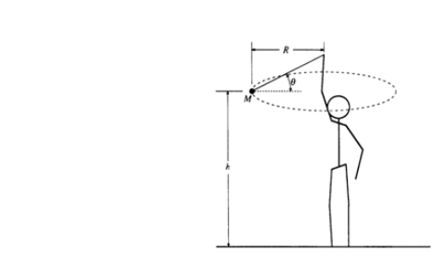

1. An object of mass M on a string is whirled with increasing speed in a horizontal circle, as shown above. When the string breaks, the object has speed vo and the circular path has radius R and is a height h above the ground. Neglect air friction.
2. Determine the following, expressing all answers in terms of h, vo, and g.
3. The time required for the object to hit the ground after the string breaks
4. The horizontal distance the object travels from the time the string breaks until it hits the ground
5. The speed of the object just before it hits the ground
6. On the figure below, draw and label all the forces acting on the object when it is in the position shown in the diagram above.
7. Determine the tension in the string just before the string breaks. Express your answer in terms of M, R, vo, and g**.**
8. (Short answer) A red car is traveling on a straight road and is speeding up with an acceleration of 5 m/s2. A blue car is traveling on a circular track of radius 20 m with a constant speed of 10 m/s. Which car has a constant acceleration? Justify your answer.

Multiple Choice Answers

1. B
2. C
3. B
4. C
5. B
6. A
7. A
8. C
9. D
10. C
11. B
12. C
13. D
14. C
15. A
16. D
17. D
18. D
19. B
20. C
21. A
22. D
23. C
24. A, B
25. B, C

Free Response Answers

1. ϴ = 11.3O
2. V = 19 m/s
3. If v >19 m/s, then f is inward  
   If v <19 m/s, then f is outward
4. a. v = 15 m/s  
   b. v = 21.1 m/s  
   c. v = 8.5 m/s
5. a. FNET = 3 Mg; FNET is pointed downwards  
   b. vO = √(3Lg)  
   c. t = 2√(L/g)  
   d. x = 2L√3
   1. 

mg

FT

FT

mg

* 1. Vmin = √(Rg)
  2. V = √(R( $\frac{T_{MAX}}{M}$– g))
  3. Velocity is upwards, acceleration is g down

1. a. E = 3.63 J  
   b. 8.2 m/s  
   c. i. 3.5 N  
    ii. 9.4 N  
   d. 1.6 m
2. a. Get n and t  
    Calculate T = $\frac{t}{n }$  
    Calculate v = 2 $πr/T$ 
   b. none, Δx = 0, also F is perpendicular to v  
   c. T = 5.5 N  
   d. % difference = 5%  
   e. i.   
     
     
     
     
     
    ii. The net force in the vertical direction must be zero. Tension must support the weight  
    iii. ϴ = 20O

FT a =

mg

1. a. i. t = √(2h/g)  
    ii. x = vO√(2h/g)  
    iii. v = √(vO2 + 2gh)  
   b.   
     
     
     
     
     
     
     
   c. T = m√($\frac{v_{O}^{4}}{R^{2} }+ g^{2}$)

mg

FT a =

1. Acceleration is a vector, which means it has both a magnitude and a direction. For acceleration to be constant, both of these things must be constant. Since the blue care is traveling in a circle, its acceleration is always towards the center of the circle; therefore it is changing direction and is not constant.